**BEWSEY LODGE PRIMARY SCHOOL**



**POSITIVE HANDLING POLICY**

|  |  |
| --- | --- |
| Date of Review | December 2022 |
| Date of next Review | December 2025 |

**Introduction**

Positive Handling refers to the range of positive behaviour support strategies used by staff at Bewsey Lodge Primary School, which focuses on de-escalation, risk and restraint reduction.

All staff have a duty of care, which includes maintaining an acceptable level of safety for all pupils and staff within the setting.

Whilst the Department for Education’s (2013) Use of Reasonable Force document states that schools do not require parental consent to positively handle a pupil, we aim to work in partnerships with parents/carers.

**Defining Positive Handling**

No legal definition of reasonable force exists, however for the purpose of this policy and the implementation of it in Bewsey Lodge Primary School the key principles of any use of physical intervention should be that it is:

**Reasonable, Proportionate and Necessary**.

Staff need to be clear why physical intervention and the type of intervention used were reasonable (i.e.: best interests of the child), proportionate (i.e.: was used as a last resort and not as a first point of call), and necessary (i.e.: to prevent people from coming to harm.)

**When Should Positive Handling Be Used?**

There are times, when physical intervention is required as a last resort. This will usually be when other de-escalation attempts have been unsuccessful and physical intervention is required to keep people safe.

There may also be unforeseen or emergency situations when physical intervention is needed.

Guidelines cannot anticipate every situation; the sound professional judgement of staff at all times is crucial.

At Bewsey Lodge Primary we focus primarily on de-escalation and diffusion strategies and will only resort to positive handling strategies if:

* **The pupil is at risk of harming them self.**
* **The pupil is at risk of harming other people, including emotional well-being.**
* **The pupil is at risk of damaging property, which could result in harm to themselves or others.**
* **The pupil is engaging in any behaviour prejudicial to maintaining the good order and discipline at the school or among any of its pupils.**

**Procedures**

* Ideally, the minimum number of staff available to deal with any incident would be two. The second person may not necessarily be involved physically but may act as a witness, offer advice and support as a critical friend or get more help if required.
* It is the aim that calm, controlled de-escalation techniques account for the majority of intervention necessary to allow our pupils to regain control.  **Physical intervention is a last resort, which should represent only a small amount of incidents requiring intervention.**
* Each pupil who has been positively handled once in school will have a Positive Handling Plan, which documents the pupil’s triggers and best de-escalation techniques for that pupil. De-escalation techniques that may be used include:
  + - Time out - a pre-arranged strategy with a pupil allowing them designated time alone, away from a situation. This is always observed and supported by a member of staff.
    - Withdrawal - removal of a pupil from a situation by a member of staff, who will then observe and support until they are ready to return.
* Following an incident pupils may be distressed so are supported at this time. Support may include, taking part in a calming activity, quiet time away from the incident, returning to work.

**Further Considerations when Positively Handling Pupils**

* A pupil should be warned orally, or with augmented communication, that physical restraint will be used unless he or she desists.
* If there is an occasion where one pupil is affecting the learning of others, it may be appropriate for the class/group to move away rather than positive handling the pupil.
* The **minimum** amount of force should be used to control the situation.
* Every effort should be made to secure the presence of other staff before applying restraint. These staff act as assistants and witnesses.
* Physical restraint should only be attempted when there is sufficient staff at hand to ensure that it can be achieved safely.
* If there is an incident where a pupil is in confrontation with a member of staff, other staff should take over and deal with the incident, if possible.
* Other pupils should not be used to help restrain a pupil.
* During restraint staff are encouraged to talk to the pupil in a quiet/soothing voice, explain why they are restraining, and tell them that they will be released if they calm down.
* As soon as it is safe, restraint should be gradually relaxed to allow the pupil to regain self-control.
* It is important that everything possible is done to prevent injury and maintain the pupil’s dignity.
* Restraint should be an act of care and control and not punishment nor should it be used as a threat.
* Physical restraint **should not** be used purely to force compliance with staff instructions where there is no immediate danger to people or property.
* Positive Handling uses the **minimum** degree of force necessary for the **shortest period of time** to prevent a pupil harming them self, others or property.
* Staff would be expected to take into consideration the pupil’s Individual Educational (IEP), Care Plan and Positive Handling Plan (PHP), when managing challenging behaviour.
* If this was unsuccessful and the situation continues to escalate staff would then be expected to request support from a member of the Senior Leadership Team.

**Record Keeping**

Any pupil assessed to be at risk of needing physical intervention will be the subject of a formally recorded Positive Handling Plan (see **Appendix 2**). This will include information on the background of the child; possible triggers/warning signals etc, strategies used fordefusing situations as well as, when necessary, the physical intervention techniques that staff would aim to use (including any that are not appropriate for the child). We would also include strategies to help the child recover. The school will discuss this proposed strategy for managing a pupil’s behaviour with the pupil’s parents/carers. Normal practice should be to, whenever possible, also involve the pupil concerned.Positive Handling Plans will be reviewed at least termly or following an incident and staff in regular contact with the pupil should be made aware of any changes to it.

Physical Intervention forms (see **Appendix 3 and 4**) must be completed within 24 hours and signed by the Headteacher or Designated Provision Manager (each pupil has a book, which contains blank forms and previously completed forms). These need to be kept for 75 years.

**Monitoring**

Monitoring of incidents will help to ensure that staff are following the correct procedures and will alert the Headteacher to the needs of any pupil(s) whose behaviour may require the use of reasonable force. Monitoring of incidents will take place on a regular basis by the Special Educational Needs Co-ordinator (SENCO) and the results used to inform planning to meet individual pupil and school needs. An annual summary of incidents that have involved the use of force are presented to the Governing Body by the SENCO.

If further support is required in relation to a member of staff or a pupil, this will be pursued through the appropriate procedures. Support may include additional training for staff, referrals to outside agencies for pupils.

**Training**

Although Team Teach training in the use of positive handling is not essential to the implementation of it, we recognise it supports staff in this area. It is the responsibility of the Headteacher to make sure that this training is available to staff. A record is kept of those who have attended and this is reviewed regularly, by members of the Senior Leadership Team, with consideration given to the needs of the staff and the pupils they are working with. For more information on Team Teach see **Appendix 1.**

**Injury to a Pupil**

Whilst the physical techniques are intended to reduce risk, there is always risk when two or more people engage to use force to protect, release or restrain. Team Teach techniques seek to avoid injury to the pupil, but it is possible that bruising or scratching may occur accidentally, and these are not to be seen necessarily as a failure of professional technique. Any such injury will be reported using the Positive Handling Form. Any injuries to pupils as a result of incidents involving restraint will be reported to the Headteacher and parents/carers. Many staff are trained in first aid and may be called upon to implement first aid or seek further guidance in the event of an injury or physical distress arising as a result of a physical intervention.

**Staff Authorised to use Positive Handling Strategies**

All members of school staff have a legal power to use reasonable force, within the context of The Education and Inspections Act 2006 and the subsequent guidance ‘Use of Reasonable Force’ DfE July 2013.

Supply staff must ensure that they are familiar with this school's policy. Appropriate guidance and support will be given if they have not undertaken Team Teach training.

Authorisation is not given to volunteers, students on placement, visitors or parents as they will not have control of pupils who may present with challenging behaviour, but will be supervised at all times.

**Health and Safety of Staff**

Under the Health and Safety at Work Act, employees have a responsibility to report any circumstances which give rise to an increased risk to their health and safety.

Staff who have, or acquire, permanently or temporarily, any medical condition that may impact on their ability to carry out pupils’ plans have a duty to report these to the Headteacher immediately, as there may be an impact on their own safety and that of colleagues and/or pupils.

Through the provision of Team Teach training, the risk of harm towards staff is reduced but it is possible for some injury to be received. All such occurrences should be treated and subsequently recorded, on the Positive Handling Form/Accident Form.

**Staff Support Following Incidents**

Any member of staff at the school involved in or witnessing a serious incident involving the use of physical hold, may require additional support following the incident. Staff should ensure that they are fully recovered from an incident before resuming their duties and colleagues are encouraged to seek and offer support where it is deemed necessary.

Where staff have been involved in an incident involving reasonable force, they should have access to support; this will be made available/supported through the Headteacher.

**Complaints**

The availability of a clear policy about reasonable force and early involvement of parents should reduce the likelihood of complaints but may not eliminate them. Where the nature of any complaint made by a pupil, parent or other person in relation to the use of physical holds within the school indicates an allegation of mishandling by a member staff, the school’s Complaints Policy will be followed. In such circumstances the investigation of the complaint/allegation and any resulting action in respect of child protection, disciplinary or other procedures will be carried out in accordance with the guidance received from the LA.

**Conclusion**

Physical Intervention is a planned positive intervention for out of control or violent behaviour when other de-escalation or limiting options have been exhausted. Through regular training, professional response and effective monitoring the risk of pupils or staff being injured is reduced and the positive relationships, which exist between staff and pupils, are maintained.

This policy is to be used in conjunction with The Safeguarding Suite of Policies.

For further information about positive handling please refer to the Warrington Borough Council guidance on positive handling and the Department for Education’s Use of Reasonable Force document.

**Appendix 1**

**Team Teach Information**

On occasions, some of our children display challenging behaviour that could put themselves, other children or staff at risk of harm or cause damage to school property. In these infrequent occasions staff might use their positive handling expertise to reduce risk. At Bewsey Lodge Primary School we use a system of positive handling called Team Teach to support children on such occasions. We ensure that a percentage of staff (including senior leaders) are trained in the use of de-escalation techniques, which form 95% of Team Teach methodology. The other 5% is concerned with the use of prompts, guides and holds. Team Teach emphasises the use of positive handling as a last resort, to be used only when all other methods of de-escalation have been exhausted. Positive Handling covers the full range of de-escalation and positive behaviour management techniques employed by staff – from calm talking and other verbal and non-verbal methods, to guides and prompts to support a child in moving in the right direction or moving out of harm’s way. Occasionally more restrictive physical interventions may become necessary, on these occasions staff may hold a child to support them through their challenging behaviour.

**Team Teach is used:**

* To promote the least intrusive positive handling strategy and a continuum of gradual and graded techniques, with an emphasis and preference for the use of verbal, non-verbal de-escalation strategies being used and exhausted before positive handling strategies are utilised.
* To enable our school to develop acceptable and authorised responses to disruptive, disturbing, angry and aggressive behaviours in a manner that maintains positive relationships and provides safety for all, by training in Team-Teach.
* To reduce the amount of serious incidents involving physical controls in all school and to emphasise the importance of exhausting behaviour management strategies in the first instance.
* To increase the awareness of staff concerning the importance of recording and reporting, monitoring and evaluating, all incidents involving positive handling.
* To provide a process of repair and reflection for both staff and children.

**Key points of Team Teach**

* Where possible, the expectation is that staff will exhaust all behavioural management strategies before they physically intervene. Where and when there is time, the physical interventions should be viewed as a "last resort option" for staff.
* Where a pupil requires repeated positive handling, the strategies and techniques will be planned for and agreed in advance. They will be written out and included in individual positive handling plans.
* Physical techniques will not be taught in isolation.
* Team Teach emphasises positive relationships as being the key element in our work with children. The physical techniques can help to protect and maintain these relationships.
* The physical techniques have sufficient range and robustness to be appropriate across the age and development range, for both the intentional and non-intentional "challenging" individual.
* The positive handling techniques provide a gradual, graded system of response commensurate with the situation, task and individuals involved, allowing for phasing up or down as dictated to by the circumstances at the time.
* The use of force will always be reasonable, proportionate and necessary.
* The aim of positive handling is for the person to calm down sufficiently so that staff can return the physical control and help find a better way.
* A calm approach with staff using (Communication, Awareness /Assessment Listening/Looking and Making Safe skills - CALM) is expected at all times when managing such situations.
* Staff will make a risk assessment, both before, during and after any serious incident involving positive handling.
* The training will aim to comply and work within "good practice" guidelines produced by government departments. Team Teach has been actively involved with consultation by government departments looking at "good practice" principles in this area. Training complies with the Human Rights Act.

**Appendix 2**

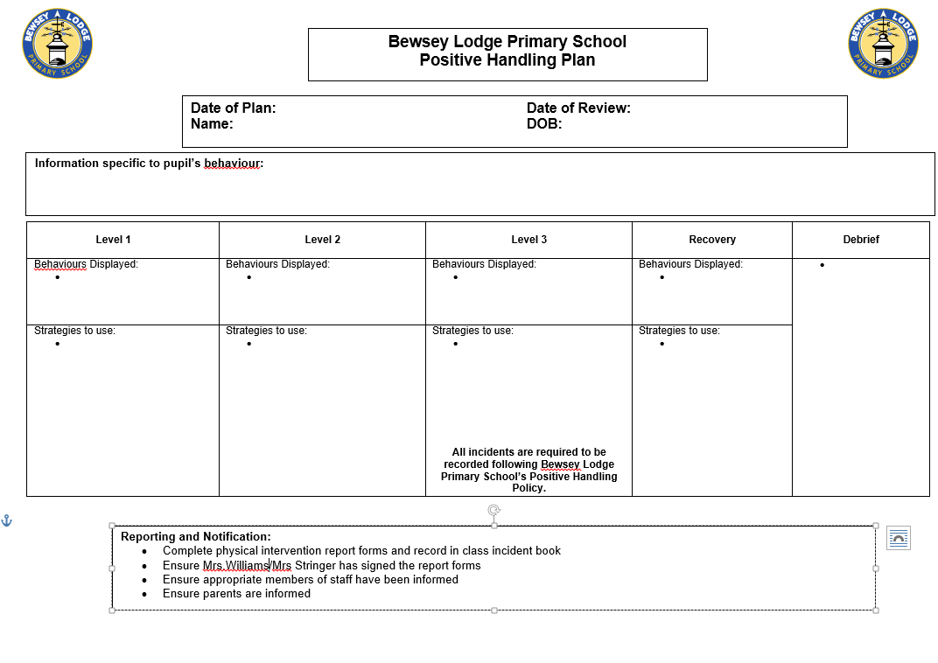

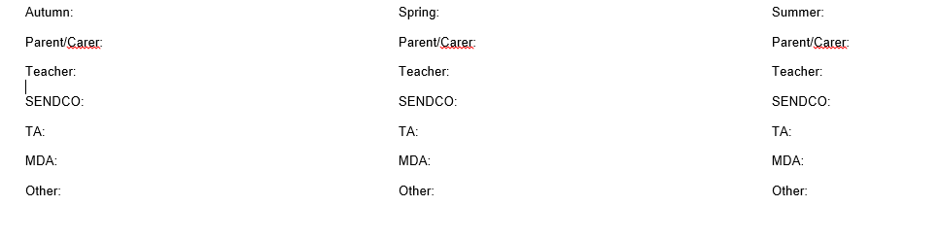

**Appendix 3**

**Physical Intervention Form – Child Consultation**

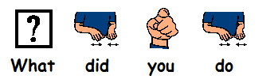

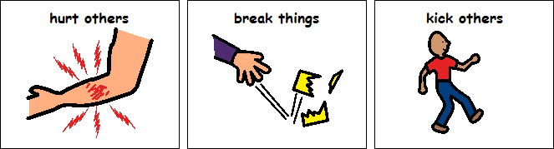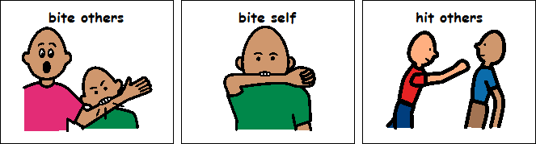







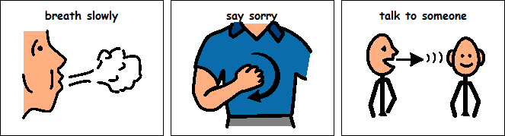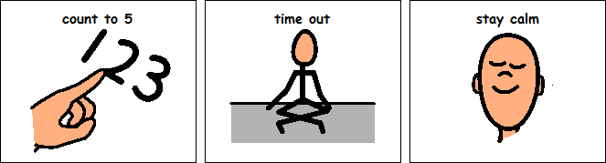

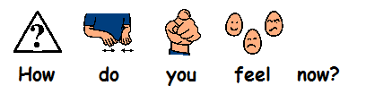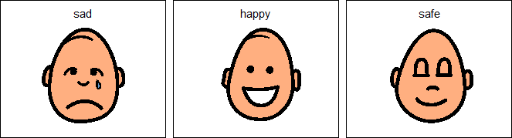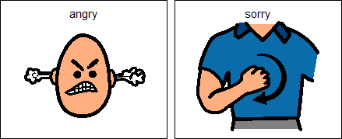

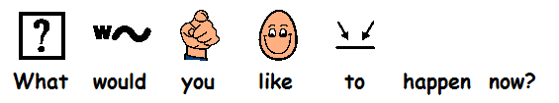

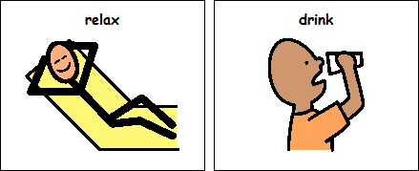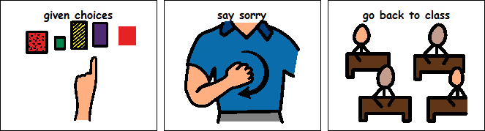

**sign ______________________ date ________**

**Appendix 4**

**Young Person Physical Intervention Report Form**

3. De-escalation techniques employed throughout P.I.

Verbal support and advice Time out

Reassurance Step away

Calm talking Distraction

Humour Removal of other pupils

Non-threatening body language other techniques

4. Approved physical intervention used position of pupil –

Friendly hold Single elbow

Guided escort Double elbow

Wrap /wrap cradle

2a. What took place leading up to the physical intervention?

2b. De – escalation prior to physical intervention?

Time P.I. started –

Time P.I. ended –

Location –

Ethnicity –

Teacher –

1. Basic Details

Name –

D.O.B. –

Class –

Date of P.I.

Pupil in public care – yes/no

Staff involved in P.I.-

Pupil witness –

Staff witness -

8. Action taken following P.I.

Opportunity for pupil to reflect and move on updated risk assessment

Consequences of behaviours opp for staff to reflect and move on

Recording of incidents Pupils offered appropriate medical assistance

Police involvement Pupil chose to seek medical advice

Details

7. Response of young person following P.I.

Calmed immediately Calmed after indirect supervised time out

Calmed after direct supervised time out Continued unsettled requiring further use of P.I.

Intervention of outside agency (i.e. police)

6. Injuries occurring prior to, during or following the P.I.

Pupil required first aid: yes/no G.P. referral/visit : yes/no Hospital referral/visit: yes/no

Other pupil first aid: yes/no G.P. referral/visit : yes/no Hospital referral/visit: yes/no

Staff required first aid: yes/no G.P. referral/visit : yes/no Hospital referral/visit: yes/no

Others required first aid: yes/no G.P. referral/visit : yes/no Hospital referral/visit: yes/no

5. Presenting Behaviours

Hit/kicked pupil/worker Biting (to others)

Attempted to hit/kick pupil/worker Damage to property

Absconding Swearing

Verbal abuse Threatening behaviour verbally

Spitting Threatening behaviour physical

Self-harm Other

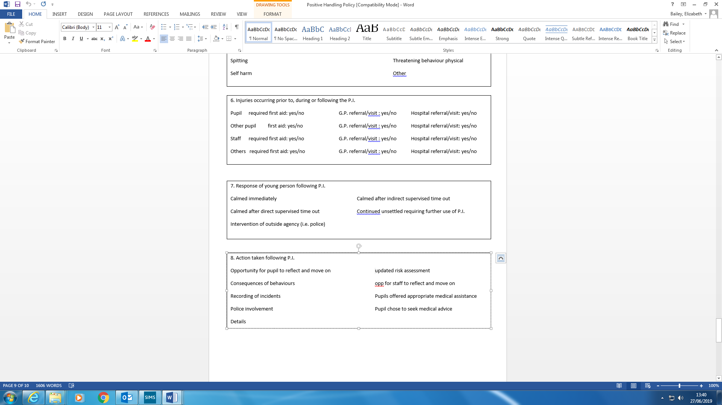

Signatures

Workers involved with P.I. Date

Pupil Date

Teacher Date

Head Teacher Date

Parties informed -

9. Pupil comments – see pupil sheet Date of completion –

Time of completion –

Staff – How have things moved on?

Action taken by Head teacher -