Topic overview

In this topic, the children learn all about the magical world of fictional stories, immersing themselves in a variety of fairy tales including ‘Little Red Riding Hood’ and ‘Jack and the Beanstalk’ to name just a few! During this topic, the children will continue to build on their early story telling skills, focusing particularly on setting descriptions and sequencing to support their development of creative writing.

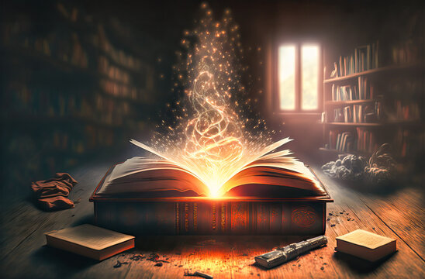

**Traditional Stories include**

* Talking animals.
* Character’s names that tell you about.
* Countryside or forest setting.
* Often repeated phrases throughout the story.
* Lesson learnt at the end of the story. Happy ending for the main characters.

**Key Vocabulary**

**Traditional tale** - A well-known story that has been retold over many years

**Setting** - The setting is the time and place in which the story happens

**Character** - A person or animal in a story

**Hero**- A hero is usually good and well-liked

**Villain** - The character that is the opposite of the hero. The villain could be mean, nasty or evil.

**Plot** - The events that make up the main part of the story

|  |  |  |  |
| --- | --- | --- | --- |
| Time Adverbials Word Bank | | | |
| After a while | Following that | Later on | Meanwhile |
| In the blink of an eye | Eventually | All of a sudden | Suddenly |

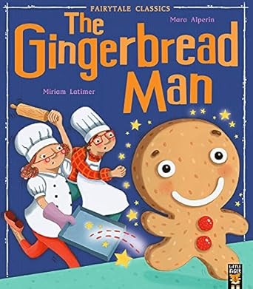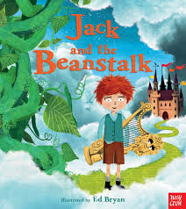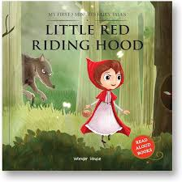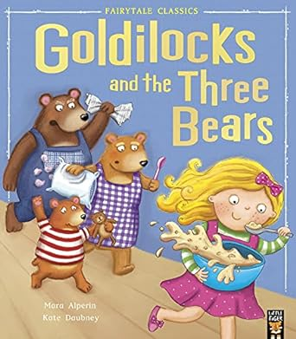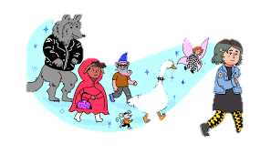

Books to read at home ..