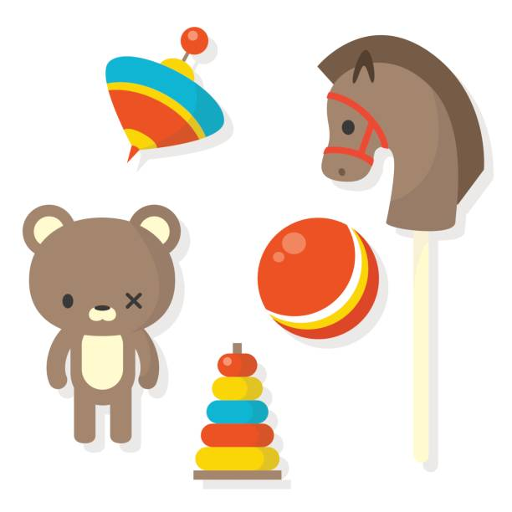 Toys Through Time

During the half term, pick and choose which activities you would like to complete as homework. You will receive 5 Diddy dots for each task completed and returned to school. All completed homework needs to be returned to school by **16th December 2024.**

|  |  |  |  |
| --- | --- | --- | --- |
| Draw a picture of your favourite toy and write a sentence about why you like it. | Can you create a timeline of toys from different periods? Ask a grown up for some help. | Research a famous old toy (like a yo-yo, teddy bear, or toy car) and create a fact sheet about it. | Act out a story with toys from home, imagining what would happen if your toys came to life. You can write or draw your story. |
| Write about what material your favourite toy is made from. | Can you design a brand new toy by drawing it, labelling it and explaining how it works? | With help from an adult, can you create a simple homemade toy (like a sock puppet, a paper kite, or a spinning top). They should bring it into school to share. | Can you create a poster or video advert for a toy from the past (e.g., a wooden train set or a spinning top)? You can highlight why it's fun and why kids would want it. |
| Ask an older member of the family what toys they played with when they were younger and why they liked them. | Create a "toy museum" at home by selecting 3–5 toys you have. You could display them, label them with the year you got them, and talk about why they are special. | Can you go on a “toy hunt” at home to find toys made from different materials (e.g., wood, plastic, fabric)? You could list the toys you find and say what they are made from. | Can you draw your favorite toy? Then, on the same page, imagine and draw what that toy might have looked like 100 years ago. |