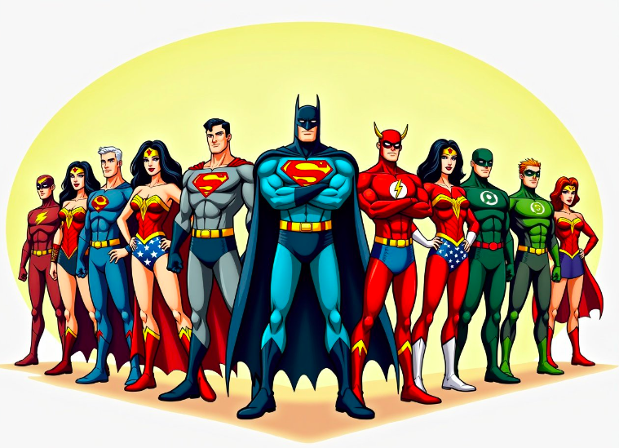**Year 1 Homework for Spring 1**

What?

You can choose as many tasks as you like, recording any writing in your homework book. Don’t forget to take pictures, too!

When?

You have over the whole half term to complete. Return for week beginning Monday 10th February for marking and a reward!

|  |  |  |  |
| --- | --- | --- | --- |
| Choose your favourite superhero and design a new outfit for them. | Design and make a new superhero gadget. What does it do? | Make a superhero mask to use in school. Be as inventive as you want. | Find out about a real life superhero from the past. You could go to the library or use the internet to get information. |
| Make a healthy hero snack. You could write the recipe or instructions when you have finished. | Can you think of a superhero for each of the letters of the alphabet? | Borrow some superhero books from the library. How many different superheroes have you read about? | Write a story about your favourite superhero. Maybe they could go on an adventure with you! |
| Create a new superhero, what powers will they have? | Think about heroes in our local area. What do they do to help us? | Choose a superhero to describe, using interesting describing words. | Create a picture of a superhero using collage materials (for example paper, tissue paper, straws, buttons, feathers, foil etc) |