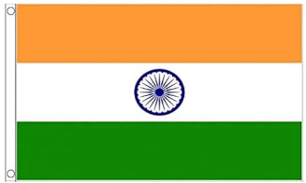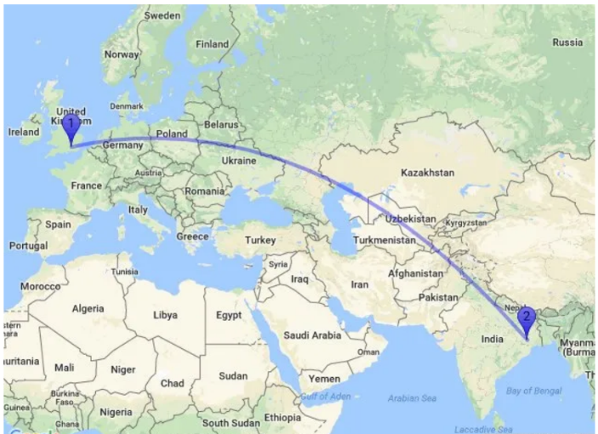

Geography knowledge Organiser: India

**Vocabulary:**

* **Geography**: The study of the Earth's landscapes, peoples, places, and environment.
* **Comparative Study**: Examining similarities and differences between two or more things.
* **UK (United Kingdom)**: A country in Europe consisting of England, Scotland, Wales, and Northern Ireland.
* **India**: A country in South Asia known for its diverse culture, history, and traditions.
* **Culture**: The way of life of a particular group of people, including their beliefs, traditions, and customs.
* **Climate**: The typical weather conditions in a region over a long period of time.
* **Landform**: A physical feature, such as mountains, valleys, or plains.
* **Agriculture**: Farming, including growing crops and raising livestock.
* **Trade**: The buying or selling of goods.

India

This half term, Year 4 will be exploring the similarities and differences between the United Kingdom and India. Students will learn about the geographical features, cultural heritage, and economic activities of both countries. By comparing the temperate climate and historical landmarks of the UK with the diverse landscapes and rich traditions of India, students will gain a deeper understanding of how human and physical geography shape these nations. This study will broaden their global perspective and appreciation for the world's diversity.

A comparison with the UK

- UK: Smaller size (243,000 sq km); India: Larger size (3.287 million sq km)

- UK: Temperate climate with mild temperatures and regular rainfall; India: Diverse climates from tropical to arid

- UK: Rolling hills, extensive coastline; India: Himalayan mountains, Ganges plains, Thar Desert

- UK: Developed economy with finance and technology sectors; India: Growing economy with agriculture and IT sectors

- UK: Rich cultural history with global influences; India: Diverse cultural tapestry with many languages and traditions

- UK: Landmarks like Buckingham Palace, Tower of London; India: Taj Mahal, Rajasthan forts, ancient temples

Overview

-India is the seventh-largest country and the second-most populated, located in South Asia. -On the border of Pakistan, China, Nepal, Bhutan, Bangladesh, Myanmar. -Next to the Indian Ocean, the Arabian Sea, and the Bay of Bengal. -Physical features include: the Himalayan mountains in the north, the plains of the Ganges River and the Thar Desert in the northwest.. -Climate ranges from tropical in the south to dry and temperate in the north, supporting a wide variety of plant and animal life.

-Major rivers like the Ganges, Yamuna, and Brahmaputra are vital for agriculture, contributing to India’s status as a leading global agricultural producer.