Silver Class

Homework Grid

|  |  |  |  |
| --- | --- | --- | --- |
| Make a list of your favourite toys. | Practice counting to 10, 20 or 100. | Practice writing your full name. | Make a toyshop and home and play shops with your grown- up. |
| Write a letter to Father Christmas or someone special to ask for a special toy. | Ask your grown-ups to find a picture of a toy that they used to play with and talk or write about it. | Go shopping for a toy for you or someone else. Look in the toyshop and find out 5 different toys. | Can you make some biscuits and decorate them? |
| Help your grown up do a job around the house. | Learn your RWI sounds. | Find something old and new in your house. Talk and write any words you can think of to describe them, eg , an old teddy. | Go for a walk and see what you notice about the change in season. |

Homework to be in by Monday December 16th. Please send pictures into school via the office.

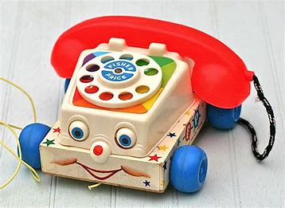Thank you

