|  |  |  |
| --- | --- | --- |
| Write a character description based on an alien from outer space. | Keep a sky at night journal for a whole week. Write about everything you can see in the sky. You could draw a picture of the moon every night. Does it change over the course of the week? | Write your own poem about space. This could be an acrostic poem for a planet or a rhyming poem. |
| Research, design and create your own rocket space ship, which could fly to space. | Can you research who was the first person to reach the moon? What facts can you find about them (e.g. nationality, age)? | Read a story and write why you would recommend it to a friend and give your personal point of view. |
| If you are able to, watch Wall-E the movie and review it. Who were the characters? What were the main events? What was your favourite part? What was your least favourite part? | Can you design a poster for NASA looking for people to join as astronauts? What features do you need to include so that your poster is eye-catching and appealing? | Make a space mobile that you could hang in the classroom. |
| Bake your own space themed cookies or biscuits. They could be star, rocket or planet shaped. They could even include space rocks such as popping candy! Record the recipe. Feel free to share your biscuits! | Create a timeline to show the history of space travel. | Can you create your own space themed top trump cards? These could be about the different planets in the solar system. |

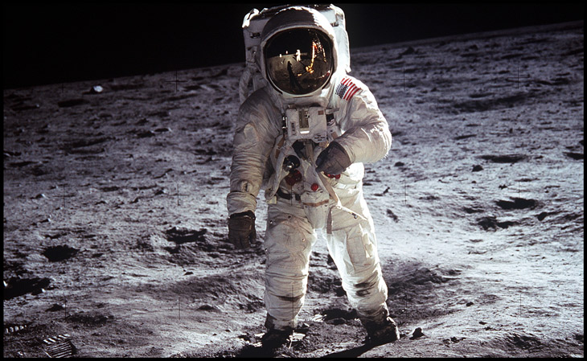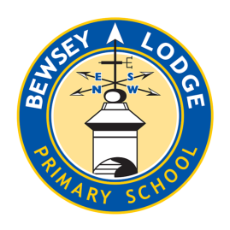

***Choose your homework from the grid below:***

You can choose as many tasks as you like. If you need a book or paper to record your work, just ask. You have the whole half term to choose and complete as much as you can.

Return on **Monday 16th December** for marking and a reward. Try to attempt **at least one** task from the top line.

**Sapphire – One Giant Step**

