|  |  |  |  |
| --- | --- | --- | --- |
| Write a letter home to a loved one.  Imagine you are in the war and have been sent away to work on the farms as part of the land army.    **Remember to use informal language and add as much detail as possible**! | Create a recruitment poster.  Make a poster to encourage women to join the land army.  Think about the jobs they will be doing and the information you will need to include. **Remember to use lots of colour to attract your audience.** | Make do and mend!  Design an item of clothing which is made from old fabric, i.e. curtains, cushion covers, bed sheets. Draw your design and label what you will use.  **Remember to include how you will stitch the different parts together!** | War time baking  Research and bake a recipe from  World War 2. Take a photo and bring it into school to show us.  **Remember – rations were in short supply so take care when measuring!** |
| What would you take and why?  Imagine you have been deployed to another city to work. Make a list of 10 items you will take with you and explain why!  **Remember, this was the 1940’s so many things you have today were not then invented!** | Who, What, Where, When, Why?  Carry out your own research about life in  WWII. What interesting things can you find out?    **Challenge: Can you find more than 10 different pieces of information?** | Perfect poetry  During the war, people would send poetry to their loved ones to tell them how they were feeling. Can you create a poem about life in the war – what would it feel like?  **Remember to use powerful descriptive language.** | Food rationing  Find out which foods were rationed during the war and make a  shopping list of all the things you’d  need to buy for a week, to feed you and your family.  **Remember, many items were restricted and you couldn’t buy more than** 1. |
| News of the world!  Imagine it is 1939 and the war has just broken out. Write a newspaper report  informing the people of Britain. What happened, why did it happen, when did it happen?  **Remember to include the features of a newspaper report: catchy heading, pictures, captions and key facts.** | Dear diary  Write a diary entry as a soldier. Imagine you have been in battle, what would you say at the end of the day? How would you feel?  What might you be missing?    **Challenge: You could even make your diary look old, using a tea bag or a brown coloured pencil.** | Timeline  Create a timeline of events, starting with the outbreak of the war until it ended in 1945.  **Remember to include all key dates and key events.** | Prepare for the blitz!  During the Blitz, Britain experienced frequent bombing  attacks from the Germans. To stay  safe, people made air raid shelters for protection. Create your own  model of a shelter using materials from around the house.  **Remember – it must be sturdy!** |

***Choose your homework from the grid above:***

You can choose as many tasks as you like. You have the whole half term to choose and complete as much as you can.



Sapphire Homework grid

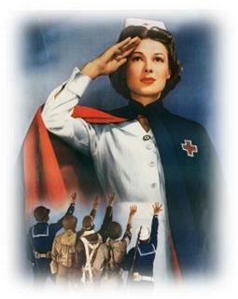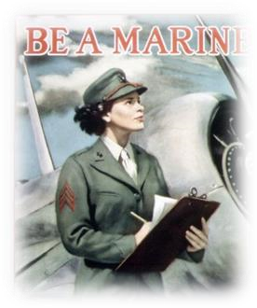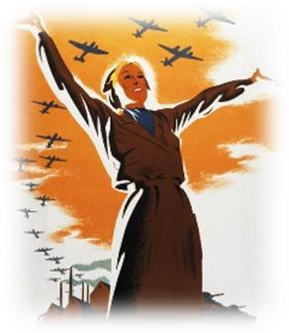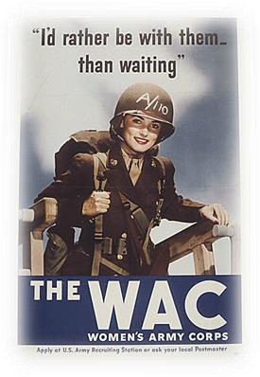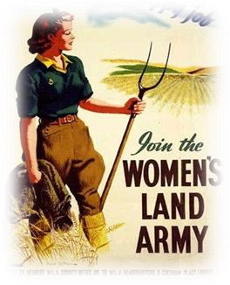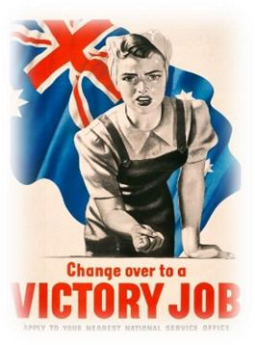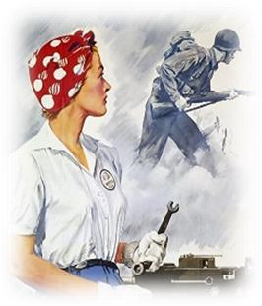

Return on **Monday 21st October** for marking and a reward. Try to attempt **at least one** task from the top line.

If you need a book or paper to record your work, just ask.