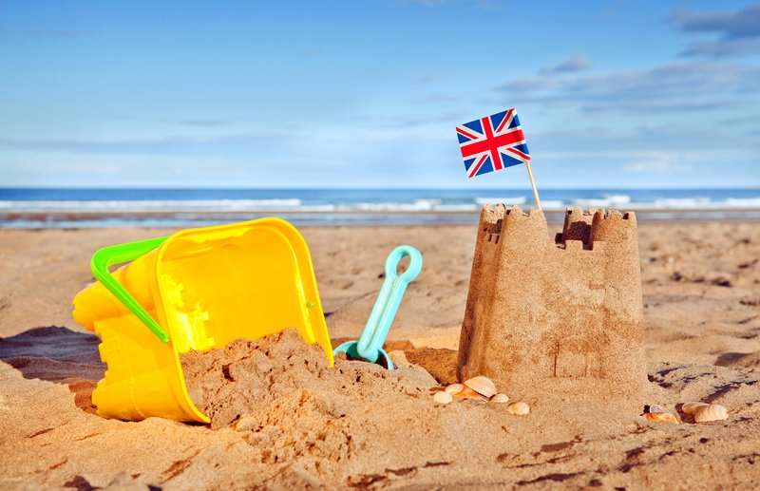
Seaside Explorers
During the half term pick and choose which activities you would like to complete as home learning. Please upload any work you do to Tapestry! If we see children taking part in the home learning tasks, they can win a prize from the cabinet! Please see your class teacher if your Log-In for Tapestry is not working. Home learning tasks are to be completed by Thursday 18th July 2024.

Draw and label a fish. Use the words scales, fin, gills, tail and eyes. | Read a story about a fish or whale. | Write a story about a seaside adventure. | Draw an aquarium with 20 fish inside and write a number on each one.
Write a list of creatures that you would find at the beach and under the sea. | Collect some seashells and make some natural art out of them. | Sing some seaside songs or poems. | Visit an aquarium (blue planet/sea-life centre/garden centres that sell fish).
Visit a library and find some books about the seaside. | Write a postcard! | Practise simple subtraction, doubling, halving and sharing. | Write down 3 facts about a creature that lives at the seaside or in the sea.

