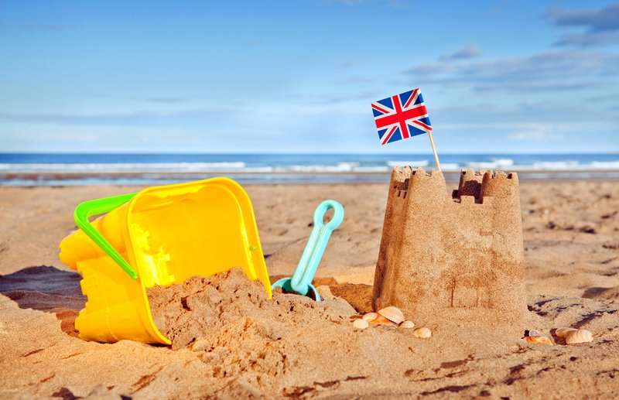

Facts we will be learning:

* Parts of a fish including; fin, scales, eyes and tail.
* Different fish habitats
* Impact of pollution on sea life
* Different ways fish/ sea creatures breathe

Stories we will be sharing:

* Sharing a shell
* Old shell new shell
* The rainbow fish
* Secret seahorse
* The snail and the whale
* Barry the fish with fingers

Key Vocabulary we will be using:

* Front cover/ back cover
* Title
* Author
* Illustrator
* Page numbers
* Blurb
* Beginning / middle / end
* Contents page
* Index
* Heading
* Label
* Glossary

Questions we will be asking:

* Can you tell me what happened in the beginning / middle / end of the story?
* What do you think happened next?
* Where can we find information?

Non-Fiction texts we will be sharing:

* Under the sea
* Big ocean creatures
* I love sharks
* Underwater, A First Look at Animals
* Discoveries Under the sea

Seaside Explorers

Knowledge Organiser

Knowle

Know