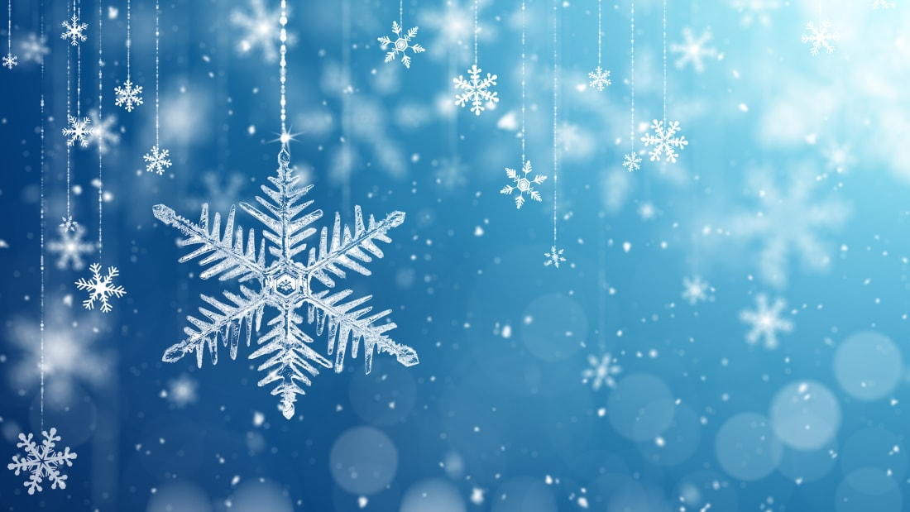

Questions we will be asking:

* Can you find the Arctic/ Antarctic on a map?
* What clothes do we need for wintery days?
* What makes a non-fiction text?
* Do polar bears eat penguins?

Stories we will be sharing:

* One Snowy Night
* Storm Whale
* Storm Whale in Winter
* Penguin
* Lost and Found

Key Vocabulary we will be using:

* winter
* seasons
* ice
* frost
* temperature
* freezing
* melting

Facts we will be learning about;

* In the UK winter starts in December.
* Seasonal changes in winter, colder temperatures, ice, fog, frost, darker nights and mornings.
* Animal migration and hibernation.
* The North Pole is in the Arctic.
* Polar Bears and people live in the Arctic.
* The South Pole is in the Antarctic
* Some penguins live in the Antarctic,
* Lots of people work in the Antarctic but do not live there permanently.
* Both the Arctic and Antarctic have deserts.

Non-Fiction texts we will be sharing:

* Animals in Winter
* What’s the Season?
* Snow and Ice
* The Story of Snow

Wonderful Winter

Knowledge Organiser

Knowle

Know