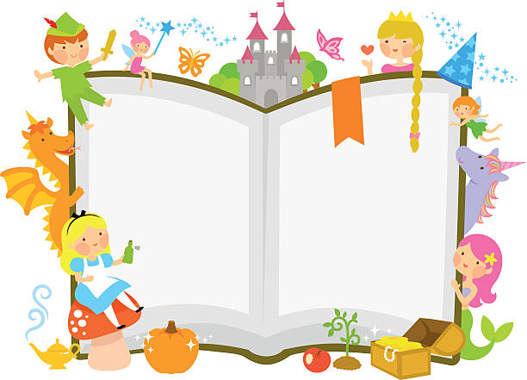

Knowledge Organiser

**Key Vocabulary**

Once upon a time

Happily, ever after

One fine day

There once was a

Long, long ago

Traditional tale

Character

Setting

Traditional Tales

This half term, we will be learning about traditional tales, their settings, characters and the story structure they usually follow.

**Key Skills**

I can recall a repeated refrain from a familiar traditional tale.

I can say where a story is set

I can identify rhyming words

I can name characters in a familiar story

**Key Texts**

The Three Little Pigs

The Little Red Hen

The Gingerbread Man

The Three Billy Goats Gruff

Little Red Riding Hood

Key Dates

Bonfire Night

Tuesday 5th November

Remembrance Day Monday 11th November

**Key People and Places**

Author

Illustrator

woods / forest

Who writw this stiry?