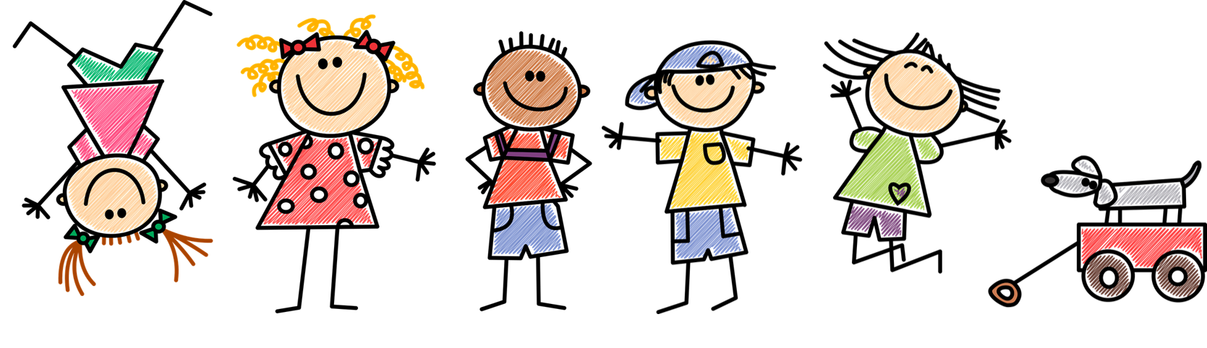

This half term, we will be learning all about ourselves and each other including, our likes and dislikes, birthday and families. We will draw pictures of our families, create personal portraits, talk about pets as well as where we live, who we live with and familiar places in our surrounding area.

**Key Vocabulary**

Mum, Dad, brother, sister, family, friend, house, home.

Happy, excited, loved, calm, sad, nervous, angry, confused.

Map, town, school, teacher, classroom, playground, road, shop, hospital, park.

Like, dislike, favourite,

**Key Skills**

I can write my own name.

I can say how old I am.

I can say when my birthday is.

I can name the different parts of my body.

**Key People and Places**

What is your name?

Who is in your family?

Who do you live with?

What town do you live in?

Knowledge Organiser

All About Me!

**Key Dates**

When is your birthday?

What special times do you and your family celebrate?

**Key Texts**

Hello Friend.

I Like Bees, I Don’t Like Honey.

Families.

I Really Want the Cake.

You Must Bring a Hat

Who writw this stiry?