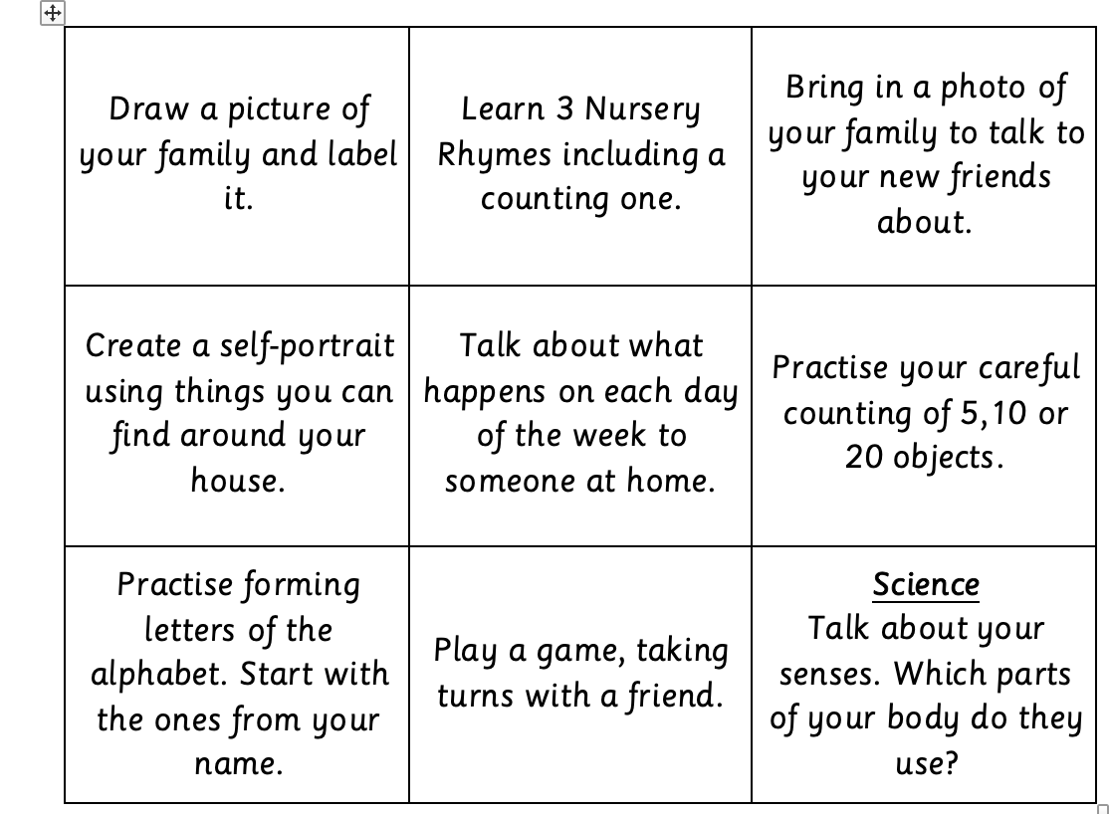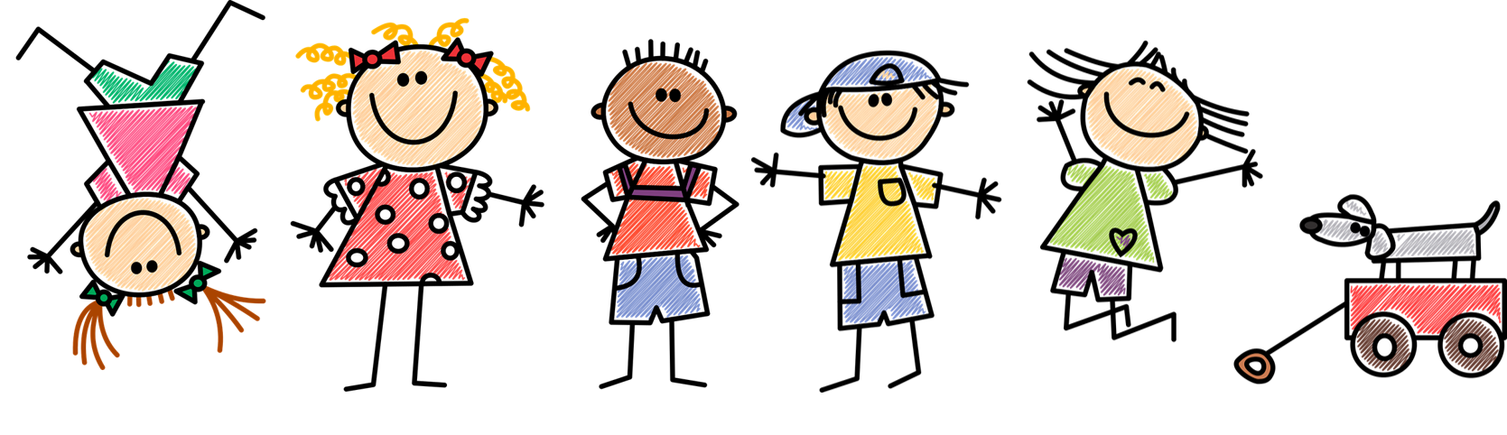

During the half term pick and choose which activities you would like to complete as homework. You will receive a prize from the prize box for completing at least half of the tasks. Add your evidence to Tapestry before the last week of half term to win!

Autumn 1 Homework

All About Me!