|  |  |  |  |
| --- | --- | --- | --- |
| Write a letter home to a loved one.  Imagine you are in the war and have been sent away to work on the farms as part of the land army.  Remember to use informal language and add as much detail as possible! | Create a recruitment poster.  Make a poster to encourage women to join the land army.  Think about the jobs they will be doing and the information you will need to include.  Remember to use lots of colour to attract your audience. | Make do and mend!  Women in the war  Design an item of clothing which is made from old fabric, i.e. curtains, cushion covers, bed sheets. Draw your design and label what you will use.  Remember to include how you will stitch the different parts together! | War time baking  Research and bake a recipe from World War 2. Take a photo and bring it into school to show us.  Remember – rations were in short supply so take care when measuring! |
| What would you take and why?  Imagine you have been deployed to another city to work. Make a list of 10 items you will take with you and explain why!  Remember, this was the 1940’s so many things you have today were not then invented! | Who, What, Where, When, Why?  Carry out your own research about life in WWII. What interesting things can you find out?  **Challenge: Can you find more than 10 different pieces of information?** | Perfect poetry  During the war, people would send poetry to their loved ones to tell them how they were feeling. Can you create a poem about life in the war – what would it feel like?  **Remember to use powerful descriptive language.** | Food rationing  Find out which foods were rationed during the war and make a shopping list of all the things you’d need to buy for a week, to feed you and your family.  **Remember, many items were restricted and you couldn’t buy more than** 1. |
| News of the world!  Imagine it is 1939 and the war has just broken out. Write a newspaper report informing the people of Britain. What happened, why did it happen, when did it happen?  Remember to include the features of a newspaper report: catchy heading, pictures, captions and key facts. | Dear diary  Write a diary entry as a soldier. Imagine you have been in battle, what would you say at the end of the day? How would you feel? What might you be missing?  **Challenge: You could even make your diary look old, using a tea bag or a brown coloured pencil.** | Timeline  Create a timeline of events, starting with the outbreak of the war until it ended in 1945.  **Remember to include all key dates and key events.** | Prepare for the blitz!  During the Blitz, Britain experienced frequent bombing attacks from the Germans. To stay safe, people made air raid shelters for protection. Create your own model of a shelter using materials from around the house.  **Remember – it must be sturdy!** |

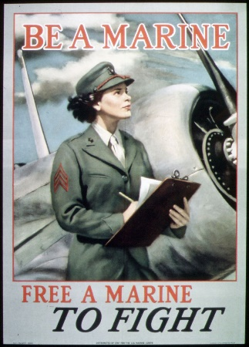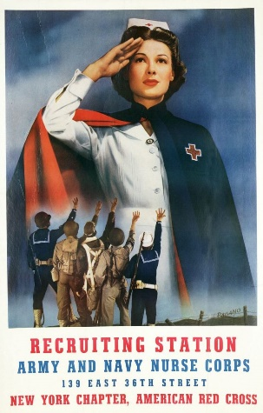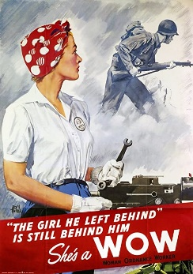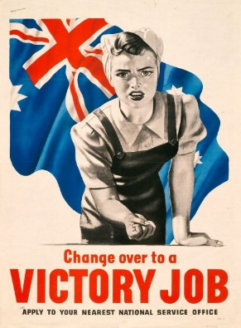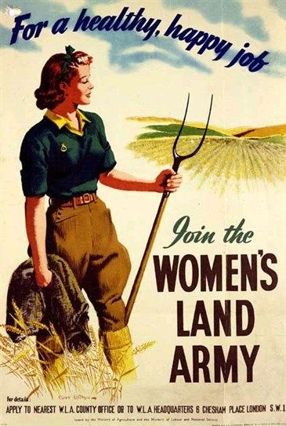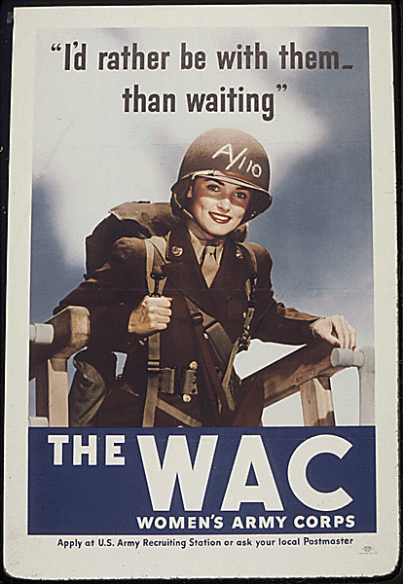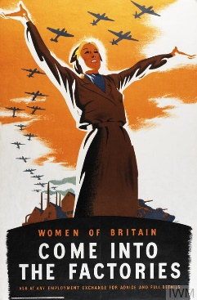

***Choose your homework from the grid above:***

You can choose as many tasks as you like. You have the whole half term to choose and complete as much as you can.

Return on **Monday 21st  Oct** for marking and a reward. Try to attempt **at least one** task from the top line.

If you need a book or paper to record your work, just ask.

Opal Homework grid