|  |  |  |
| --- | --- | --- |
| Draw and label the different parts of any flower of your choice - creating a detailed diagram. | Create a fact file on a creature (such as a butterfly, frog or chick) which describes each stage of its life cycle. | Find a photo of yourself as a baby; write down what changes you can see. How have you changed in personality? |
| Go on a walk and record different types of animals, trees and plants you spot. What are the most common/unique? | Write a short story based on a creature that begins as an egg and transforms into a creature of your choice, such as a butterfly or frog. Make sure you include lots of description! | Plant a seed and log the changes in a daily diary. What can you see changing? Note them down along with your contributions to make it change. |
| Create a set of picture cards which match the creature to its first form before its transformation e.g. tadpole to frog. | Create your own word search which includes our topic vocabulary e.g. life cycle, growth, metamorphosis. | Visit a garden centre and look at the seeds and plants at different stages of growth. Take pictures! |

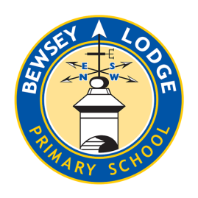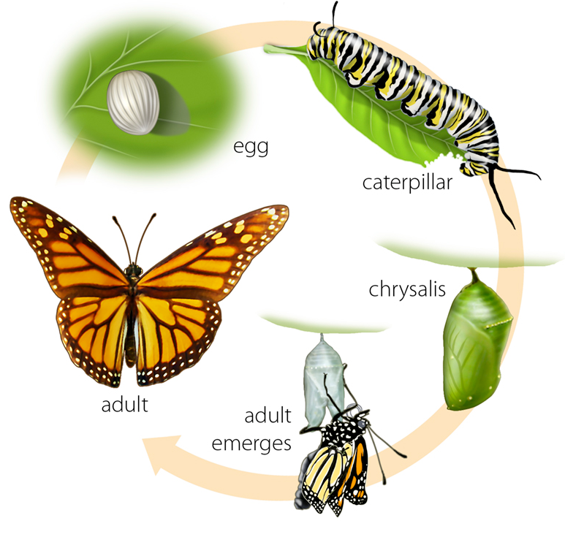

***Choose your homework from the grid below:***

You can choose as many tasks as you like. If you need a book or paper to record your work, just ask. You have the whole half term to choose and complete as much as you can.

Return on **Monday 19th May** for marking and a reward.

**Opal– Changes**

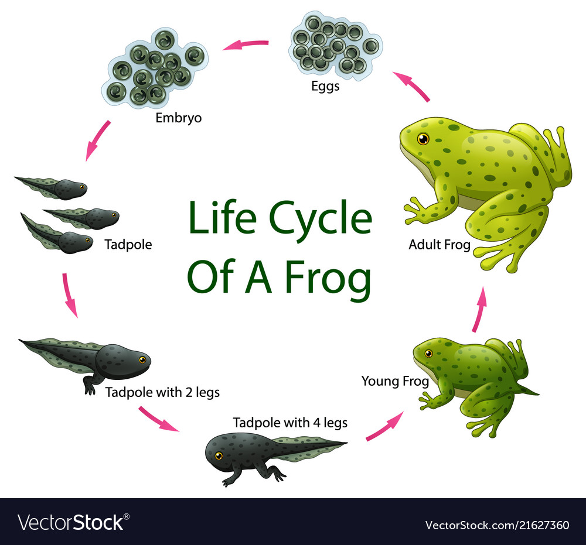

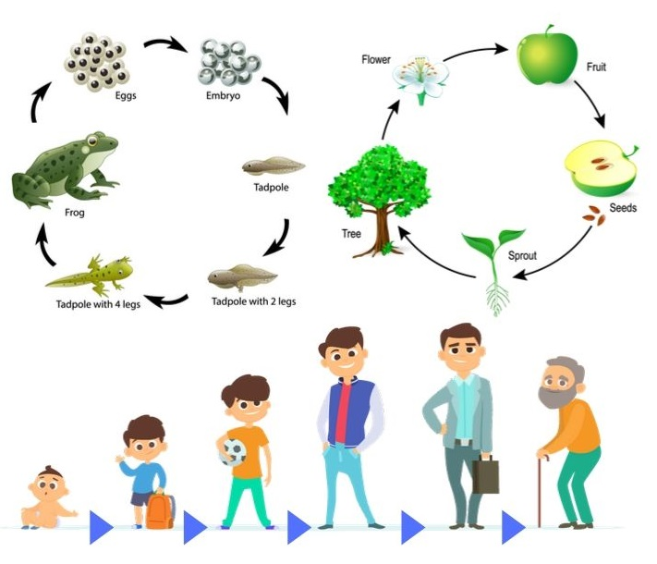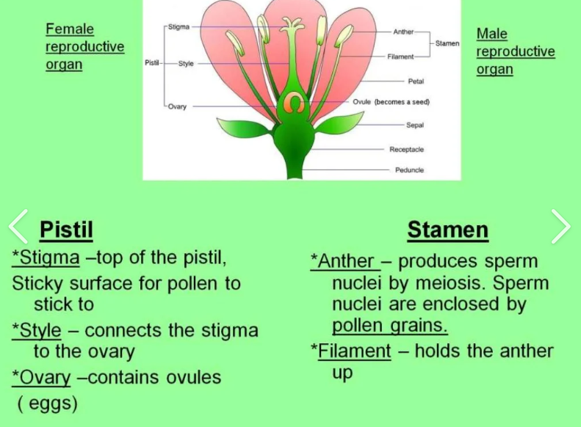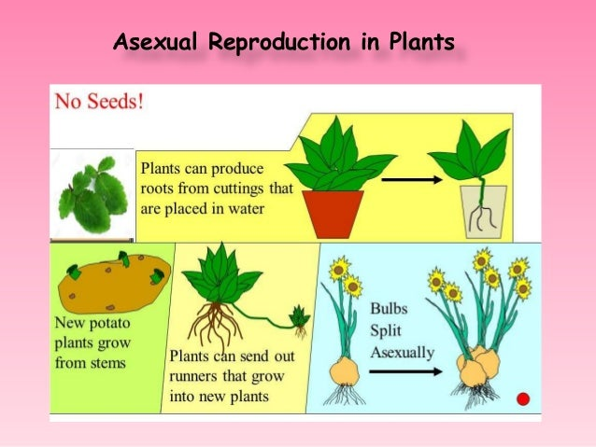

Can you guess what life cycle each of these are showing? Look at how each one starts their journey into adulthood.

[**Life cycles** show how living things grow and change over time. Here are some key points about life cycles:](https://www.bing.com/ck/a?!&&p=debb4aa0b0049c8cf0cf303ffc9f96a50165d38c61e639368e42c306826ab6f6JmltdHM9MTc0MzM3OTIwMA&ptn=3&ver=2&hsh=4&fclid=288d3a5a-57e0-60cc-1b45-284756d061c4&psq=life+cycles+for+kids&u=a1aHR0cHM6Ly93d3cuZ2VuZXJhdGlvbmdlbml1cy5jb20vdmlkZW9sZXNzb25zL2FuaW1hbC1hbmQtcGxhbnQtbGlmZS1jeWNsZXMtdmlkZW8tZm9yLWtpZHMv&ntb=1)

1. [**Plants start as seeds and most form flowers and fruit**.](https://www.bing.com/ck/a?!&&p=debb4aa0b0049c8cf0cf303ffc9f96a50165d38c61e639368e42c306826ab6f6JmltdHM9MTc0MzM3OTIwMA&ptn=3&ver=2&hsh=4&fclid=288d3a5a-57e0-60cc-1b45-284756d061c4&psq=life+cycles+for+kids&u=a1aHR0cHM6Ly93d3cuZ2VuZXJhdGlvbmdlbml1cy5jb20vdmlkZW9sZXNzb25zL2FuaW1hbC1hbmQtcGxhbnQtbGlmZS1jeWNsZXMtdmlkZW8tZm9yLWtpZHMv&ntb=1)
2. [**Animals start from eggs or live birth, then grow up and mate**.](https://www.bing.com/ck/a?!&&p=debb4aa0b0049c8cf0cf303ffc9f96a50165d38c61e639368e42c306826ab6f6JmltdHM9MTc0MzM3OTIwMA&ptn=3&ver=2&hsh=4&fclid=288d3a5a-57e0-60cc-1b45-284756d061c4&psq=life+cycles+for+kids&u=a1aHR0cHM6Ly93d3cuZ2VuZXJhdGlvbmdlbml1cy5jb20vdmlkZW9sZXNzb25zL2FuaW1hbC1hbmQtcGxhbnQtbGlmZS1jeWNsZXMtdmlkZW8tZm9yLWtpZHMv&ntb=1)
3. [**All life cycles start at birth, end with death, and involve growth and reproduction**.](https://www.bing.com/ck/a?!&&p=debb4aa0b0049c8cf0cf303ffc9f96a50165d38c61e639368e42c306826ab6f6JmltdHM9MTc0MzM3OTIwMA&ptn=3&ver=2&hsh=4&fclid=288d3a5a-57e0-60cc-1b45-284756d061c4&psq=life+cycles+for+kids&u=a1aHR0cHM6Ly93d3cuZ2VuZXJhdGlvbmdlbml1cy5jb20vdmlkZW9sZXNzb25zL2FuaW1hbC1hbmQtcGxhbnQtbGlmZS1jeWNsZXMtdmlkZW8tZm9yLWtpZHMv&ntb=1)
4. [**Different generations of animals may have different forms**. For example, some animals undergo metamorphosis, while others reproduce asexually](https://www.bing.com/ck/a?!&&p=909c08df2932b29cb9b22f5464e3dabdca77f3fa07e932709c1361e9539325f7JmltdHM9MTc0MzM3OTIwMA&ptn=3&ver=2&hsh=4&fclid=288d3a5a-57e0-60cc-1b45-284756d061c4&psq=life+cycles+for+kids&u=a1aHR0cHM6Ly9raWRzLmtpZGRsZS5jby9MaWZlX2N5Y2xl&ntb=1)

Sexual Reproduction in Plants

**Year 5 Knowledge Organiser – Changes**