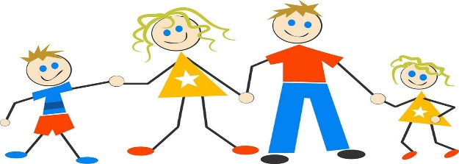 **OURSELVES** 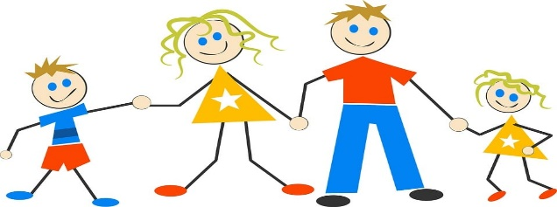

Our topic this half term is ‘OURSELVES’ during the half term we will be having lots of fun. We will be making self-portraits, talking about ourselves and our families, singing lots of songs and taking part in lots of messy play!!!!

* Can you name some of your body parts? What do we use each body part for?

* Who lives in your house? Can you draw them?
* What are your likes and dislikes? Can you talk about them with your grown-ups?

Can you read this story with a grown up and talk about it? 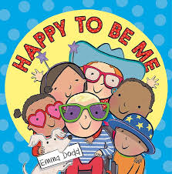

**Key vocabulary**

Mum, Dad, Brother, Sister, like, don’t like, friends, home, eyes, ears, nose, mouth, hair