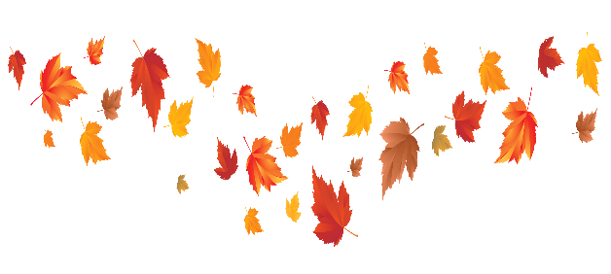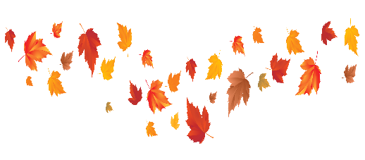**Autumn**

Our topic this half term is Autumn. During the term, we will be taking part in an autumn walk and looking at all of the different signs of autumn. We will also be reading “Wow Said The Owl and Owl Babies”.

During the last two weeks of term, we will be focusing on **CHRISTMAS!**

**Key Dates**

Bonfire Night - Tuesday 5th November

Remembrance Day - Monday 11th November

**Key Vocabulary**

cold, frosty, windy, pine cones, acorns, pumpkins, hat, scarf, gloves, leaves, red, orange, yellow, brown, crunchy, hedgehog, squirrel

Can you go on anautumn walk? What can you see?

Can you make an owl from the Owl Babies story?

Can you make a firework picture?

Can you see any autumn animals on your walk?

**Key Texts**

This half term we will be reading:

Wow said the Owl

Owl Babies

Leaf Man

Percy the Park Keeper