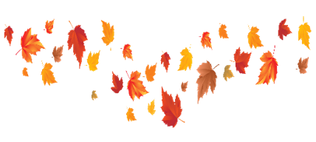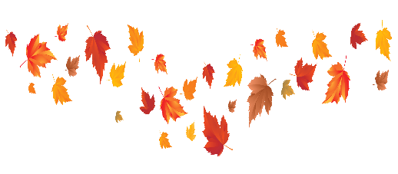**Autumn**

During the half term, pick and choose which activities you would like to complete as homework. You will receive a prize from the prize box for completing at least half of the tasks. Add your evidence to Tapestry or hand it to one of your teachers before the last week of half term to win!

|  |  |  |
| --- | --- | --- |
| Go on an Autumn walk.  What can you see? | Can you find any conkers when you go for a walk? | Can you make a picture with some fallen leaves? |
| Can you talk about clothing we might need to wear in the Autumn? | Draw a picture of a tree in Autumn. | Can you make a snail using one of the conkers you have found?  C:\Users\Student\Desktop\conker snail.jpg |
| Ask a grown up to read the story ‘Owl Babies’ and talk about what happens in the story. | Can you count to 10? | Can you find big and little objects around your house and sort them into two groups? |