Learning opportunities throughout the nursery day promote learning across multiple areas of development, the information below summarises our topic based learning experiences.
Communication & Language:
- enjoy listening to longer stories & talk about them, remembering much of what happens
- begin to understand more words, use a wider vocabulary & sentences of 4 – 6 words
- understand ‘why’ questions eg “why do you think the caterpillar got so fat?”
- start a conversation with an adult or a friend & continue it for many turns
- use talk to organise themselves & their play eg “Let’s go on a bus … you sit there … I’ll be the drier”

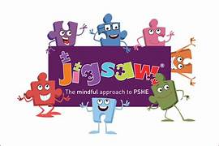

Physical Development:
- use & remember sequences of movements ref. music & rhythm
- use one handed tools & equipment eg making snips in paper with scissors
- use a comfortable grip with good control when holding pens & pencils
- start taking part in group activities made by themselves in teams
- develop self-help skills eg zipping/buttoning their coat, putting on wellingtons …

Development in this area permeates everything, specific lessons use a scheme called Jigsaw.
Personal, Social & Emotional Education:
Relationships
- week 1 – know how to make friends
- week 2 – try to solve friendship problems when they occur
- week 3 – help others to feel part of a group
- week 4 - how respect by how we treat each other
- week 5 – help selvess & others when upset/hurt week 6 – know & show what makes a good relationship

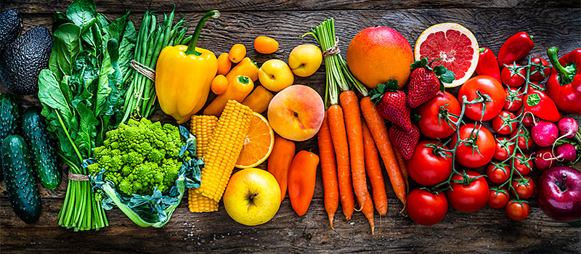
Literacy:
- develop phonological awareness:
  - spot & suggest rhymes
  - count or clap syllables n a word
  - recognise words with the same initial sound
- use some of their print & letter knowledge;
  - in early writing eg. a shopping list, ‘m’ for mummy
  - write some or all of their name
  - write some letters accurately
- engage in extended conversations about stories, learning new vocabulary

- use some of their print & letter knowledge;
in early
Mathematics:
- recite numbers past 5
- recognise 3 objects ‘subitising
- show finger numbers up to 5
- link numerals & amounts up to 5
- compare quantities ‘more than’, ‘fewer than’
- make comparisons between objects relating to size, length, weight & capacity
- combine shapes a bigger triangle …

Expressive Arts & Design:
- make imaginative & complex ‘small worlds’
- join different materials & explore different textures
- create closed shapes with continuous lines & begin to use these to represent things
- draw with increasing complexity & detail spring flowers
- explore colour & colour mixing
- pitch match when singing
- play instruments to express feelings & ideas

Understanding the World:
- use senses in hands-on exploration
  - week 1 – outdoor learning focus, planting allotment
  - week 2 – planting beans & rowing beanstalks
  - week 3 – set up a farm shop in Nursery
  - week 4 – making vegetable soup
  - week 5 – tasting a fruit rainbow & making fruit salad
  - week 6 – forest school
- use a wide vocabulary to talk about what is seen
- respect & care for nature

