Learning opportunities throughout the nursery day promote learning across multiple areas of development, the information below summarises our topic based learning experiences.
Communication & Language:
- enjoy listening to longer stories & talk about them, remembering much of what happens
- begin to understand more words, use a wider vocabulary & sentences of 4 – 6 words
- understand ‘why’ questions eg “why do you think the caterpillar got so fat?”
- be able to express a point of view & to debate when they disagree
- use talk to organise themselves & their play eg “Let’s go on a bus … you sit there … I’ll be the drier”

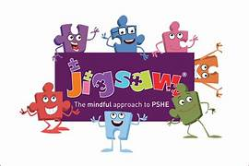

Development in this area permeates everything, specific lessons use a scheme called Jigsaw.
Personal, Social & Emotional Education:
Changing Me
- week 1 – name parts of my body and show respect for myself
- week 2 – say some things I can do and some food I can eat to be healthy
- week 3 – understand that we all start as babies and grow into children and then adults
- week 4 - know that I grow and change
- week 5 – talk about how I feel moving to School from Nursery week 6 – remember fun things about Nursery aboutNursery rerememberrememfuthings about Nurserythings about Nursery

Physical Development:
- use & remember sequences of movements ref. music & rhythm
- choose the right resources to carry out their own plan
- use a comfortable grip with good control when holding pens & pencils
- start taking part in group activities made by themselves in teams
- develop self-help skills eg zipping/buttoning their coat, putting on wellingtons …

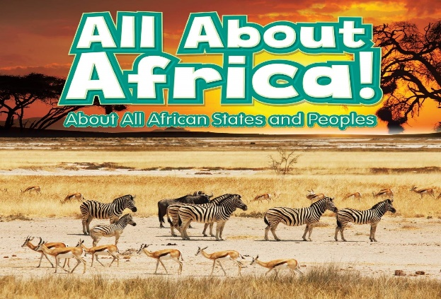
Literacy:
- develop phonological awareness
  - spot & suggest rhymes
  - count or clap syllables n a word
  - recognise words with the same initial sound
- use some of their print & letter knowledge;
  - in early writing eg. a shopping list, ‘m’ for mummy
  - write some or all of their name
  - write some letters accurately
- engage in extended conversations about stories, learning new vocabulary

- use some of their print & letter knowledge;
in early
Mathematics:
- recite numbers past 5
- recognise 3 objects ‘subitising
- show finger numbers up to 5
- link numerals & amounts up to 5
- compare quantities ‘more than’, ‘fewer than’
- make comparisons between objects relating to size, length, weight & capacity
- discuss routes & locations…

Expressive Arts & Design:
- make imaginative & complex ‘small worlds’
- join different materials & explore different textures
- use drawings to represent ideas such as movement, loud noises …
- draw with increasing complexity & detail spring flowers
- show different emptions in their drawings
- pitch match when singing
- play instruments to express feelings & ideas

Understanding the World:
- use senses in hands-on exploration
- use a wide vocabulary to talk about what is seen
- respect & care for nature
- explore & talk about different forces they can feel
- talk about materials & changes they notice
- continue developing positive attitudes about the differences between people
- know there are different countries & compare

