Learning opportunities throughout the nursery day promote learning across multiple areas of development, the information below summarises our topic based learning experiences.
Communication & Language:
- enjoy listening to longer stories & talk about them, starting to remember parts of a story
- begin to understand more words & use a wider vocabulary
- follow an instruction that has two parts eg “Get your coaat & wait at the door please.”
- enjoy & learn rhymes eg “Incy, Wincy Spider”
- use talk to organise themselves & their play eg “Let’s go on a bus … you sit there … I’ll be the drier”

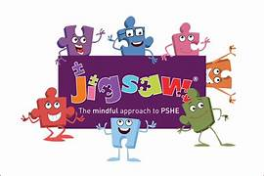

Physical Development:
- develop movement, balancing, riding scooters, bikes, trikes, & ball skills
- use large muscle movements to wave flags, pain & make marks
- match physical skills to a task eg decide to crawl, walk or run across a plank
- collaborate with others to manage large items eg a large empty box
- develop self-help skills eg zipping/buttoning their coat, putting on wellingtons …

Development in this area permeates everything, specific lessons use a scheme called JJigsaw.
Personal, Social & Emotional Education:
Being Me in My World
- week 3 – self identity
- week 4 – understanding feelings
- week 5 – being in a classroom
- week 6 - being gentle
- week 7 – rights & responsibilities

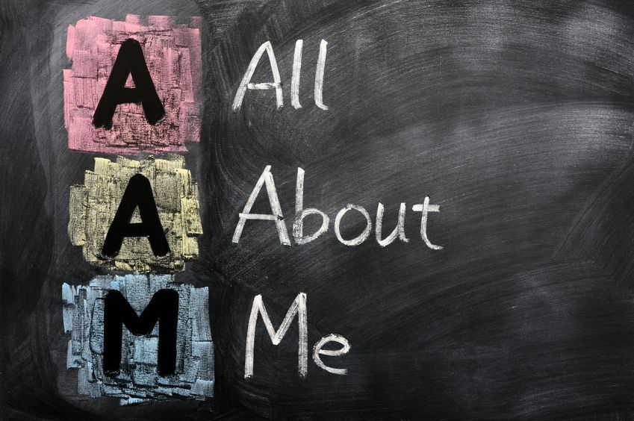
Mathematics:
- recite numbers past 5
- say 1 number for each item in order
- know that the last number when counting a small set of objects tells you how many.
- understand positions eg the bear is under the table
- select shapes a triangular prism to add a roof
- talk about & identify patterns in nursery eg stripes on clothes, circles on mats …
Literacy:
- understand the 5 key concepts about print:
  - print has meaning
  - print can have different purposes
  - we read English text left to right & top to bottom
  - names of different parts of books
  - page sequencing
- develop phonological awareness;
  - spot & suggest rhymes
  - count/clap syllables in a word
  - recognise words with the same initial sound

Expressive Arts & Design:
- enjoy simple pretend play using objects to represent things
- explore materials; how to use them & what they can make
- create closed shapes with continuous lines & begin to use these to represent things
- draw with increasingly complexity & detail eg a fae
- listen with increased attention to sounds
- remember & sing songs
- sing the pitch of a tone sung by another person

Understanding the World:
- use senses in hand-on exploration
  - week 3 – hearing
  - week 4 – taste
  - week 5 – touch
  - week 6 – smell
  - week 7 – sight
- begin to make sense of their life-story
- show an interest in different occupations

