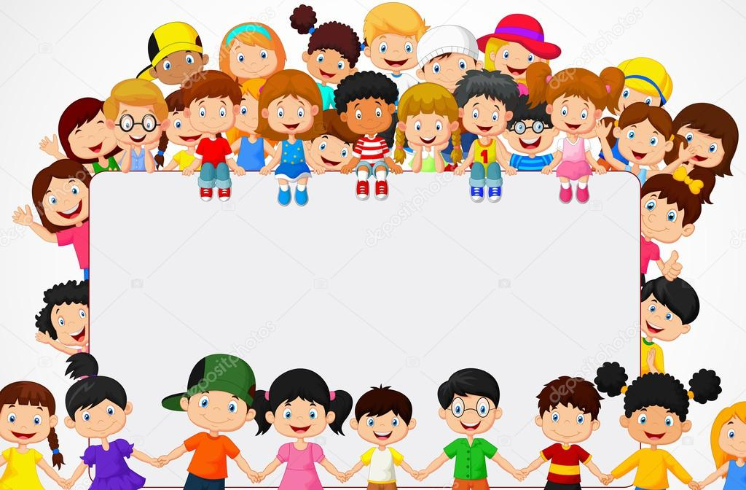
Happy to be Me
During September and October we will be learning about ourselves.

Take a look in the mirror; which features do you see? Can you describe them? “I have short, spikey blonde hair”, “I have 2 blue eyes” … | Your 10 fingers are made for maths; count them, show a number, sing finger rhymes …  Here are some rhyme cards to help you learn. | Read or watch “You Choose” Pippa Goodhart & Nick Sharratt  https://www.clickabook.co.uk/product/you-choose-pippa-goodhart-nick-sharratt/  make choices, imagine, express preferences … | Heads shoulders, knees & toes ...  https://www.youtube.com/watch?v=ZanHgPprl-0  have fun learning the actions & the words!
Watch “Something Special” https://www.youtube.com/watch?v=pIbm8_c86qc & on iPlayer  Can you learn some Makaton sign language? | Enjoy exercise;  Can you hop, skip, jump? Can you roll, catch & bounce a ball? | Read or watch  “Only One You”  Linda Kranz  https://www.youtube.com/watch?v=IyIfExitwkQ | Create a digital scrapbook of you, your family & your friends. Take photos of times you have with your family & friends. Look at these together, zoom in on details & discuss.
Read or watch  “What Makes Me a Me?”  Ben Faulks & David Tazzyman  https://www.youtube.com/watch?v=M3imlVnPvC8 | Cook a family meal:  chicken & apple curry  Use the recipe card to buy the ingredients you need & cook the curry together. | Draw & paint pictures of yourself, your family, your friends, your house … | Make a delicious treat:  chocolate fridge cake  Use the recipe card to buy the ingredients you need & make the cake together. Who will you share it with?

