***Choose your homework from the grid below:***

You can choose as many tasks as you like. If you need a book or paper to record your work, just ask. You have the whole half term to choose and complete as much as you can.

|  |  |  |
| --- | --- | --- |
| Create a fact file about an animal in North America.  **Remember to use sub-headings and include interesting facts.** | Write an adventure story with characters like real life adventurers Lewis and Clark.  (Google Lewis& Clark expedition).  **Remember to describe the setting and use dialogue.** | Imagine you are travelling with Lewis and Clark. Write a diary about your experiences.  **Remember to use your 5 senses.** |
| Make a model of your favourite North American animal using clay, play dough or reclaimed materials. | Design a back- pack to go travelling with. What tools and food would you need on an adventure across North America? | Create a fact file on the Mississippi. Maybe include a mnemonic to remember the spelling! |
| Create a word search using topic words used this half term including:  **Climate, Mississippi, Louisiana, vegetation, culture, weather…** | Create a collage of a hurricane – use a variety of textures to create it e.g. bubble wrap, sweet wrappers, newspaper or magazines. | Create a quiz on North America – including 10-15 questions on topics including history, geography and popular culture. |
| Create your own glossary using our most important topic vocabulary  (see our knowledge organiser). | Design a travel poster, encouraging people to visit North America. Include key places to visits and experiences to have. | Research how an animal from North America has adapted to their environment. |

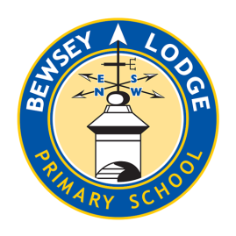 Return on **Monday 10th February** for marking and a reward. Try to attempt **at least one** task from the top line.