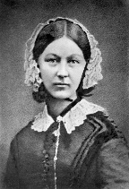

**Key people**

**Florence Nightingale**

*1820-1910*

Called the Lady of the lamp.

she helped improved nursing.

**Robert Peel**

*1788 - 1850*

In 1889, he created the first

official police force in London.

**The Wright Brothers**

1903

In 1903, the Wright Brothers

created and successfully

flew the first ever plane.

**Jesus**

Born on 25th December.

The Christian faith believes

He is the Son of God.

**Key Vocabulary**

**Monarch** – a King or Queen.

**Source** – a place where you can find evidence

**Past** – something that has already happened.

**Present** – something that is happening now or recently.

**Similarities** – things that are the same.

**Differences** – things that are different.

**Timeline** – events in the order in which they happened.

Topic overview

In this topic, children learn all about significant individuals in the past that could be seen as heroes for their accomplishments. They will learn about the impact of these accomplishments and how they affect our lives today.

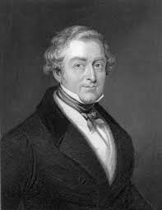

**Key images**

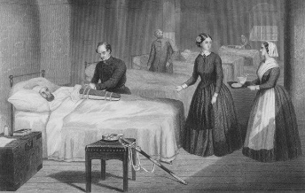

Florence and her nurses cleaned up the hospitals and made them safer places for people to recover in.

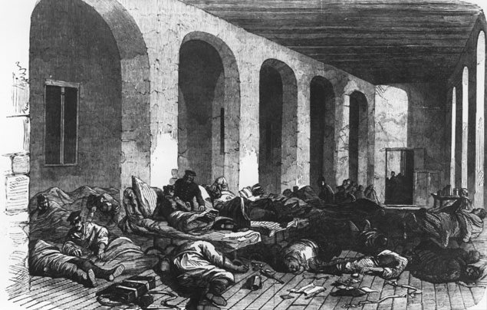

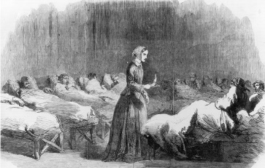

Florence would visit the wards at night time with her lamp and help the wounded men read and write letters. They called her ‘The lady of the lamp’.

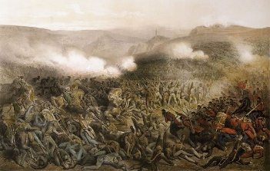

The Crimean War broke out in 1854 and Florence the nurse was sent to help.

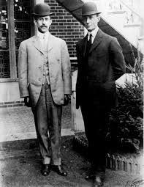

The hospitals were very dirty so the wounded weren’t getting better.

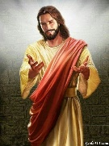

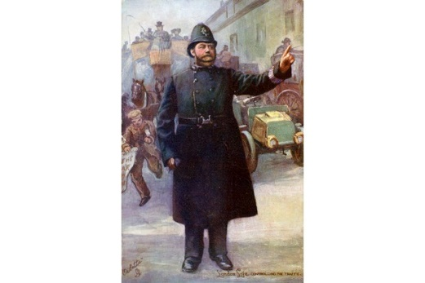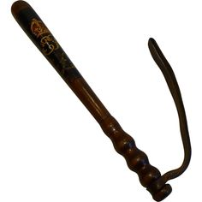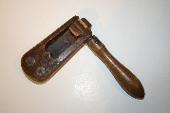

**Interesting facts**

* Florence Nightingale was named after the City she was born in – Florence in Italy.
* Robert Peel was the Prime Minister of England twice!
* When she was making the hospitals better, Florence used her own money to buy medical equipment and food.
* The Wright Brothers’ interest in flight was sparked by a toy helicopter that was given to them by their father.

Bobbies wore a dark blue uniform because Robert Peel wanted them to look different to the soldiers who wore red. He didn’t want people to be fearful of them.

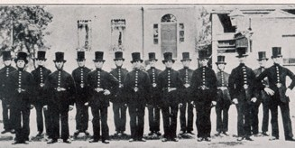

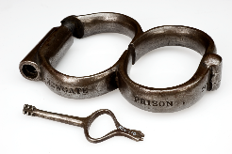

Bobbies equipment was very different to today: a wooden truncheon, handcuffs and a wooden rattle to get attention.

29th September 1829 the first 1000 Policemen or ‘Bobbies’ began working in London.

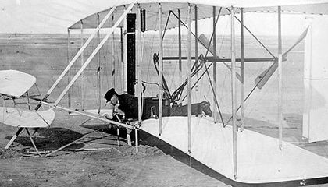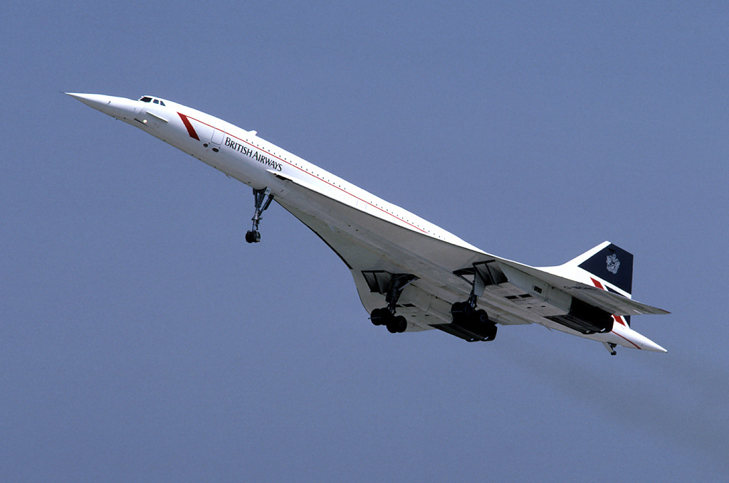

Concorde is the fastest plane that has ever been built. It could travel from London to New York in under 3 hours.

The Wright Flyer was the first plane to successfully fly. It took a few attempts but then it managed to stay up for 59 seconds.

Mrs Mullen and Mr Geaney

Word War 1

First flight

First police force

Stone age (cave man)

Dinosaurs

Birth of Jesus

Victorians

Crimean War

Gunpowder plot

Tudors

Our Timeline