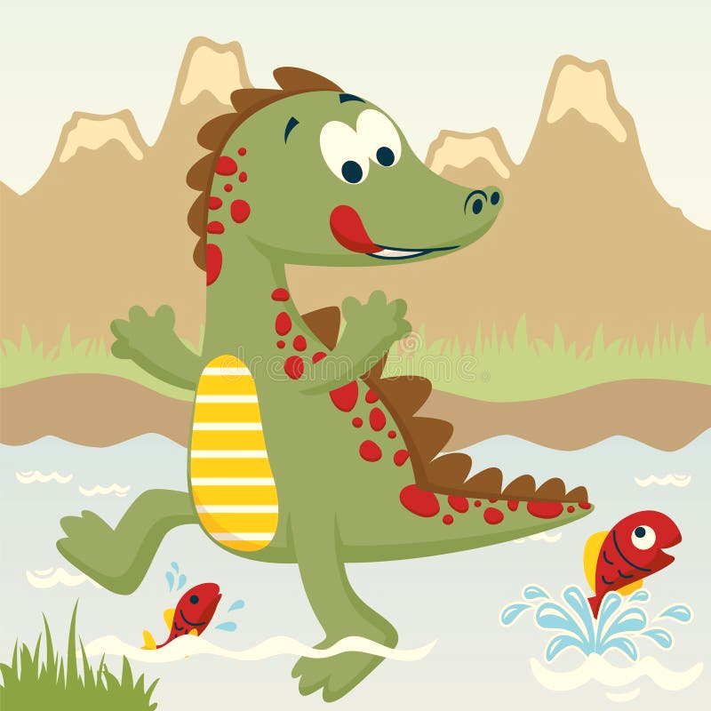**Year 1 Homework for Summer 1**

What?

You can choose as many tasks as you like. Don’t forget to take pictures, too!

When?

You have over the whole half term to complete. Return for week beginning Monday 19th May for marking and a reward!

|  |  |  |  |
| --- | --- | --- | --- |
| Draw and label a picture of a trap to catch a dinosaur and write a few sentences about how it works. | Go on a "dinosaur hunt" in the garden or park, looking for footprints (or making some with playdough or paint). | Act out catching a dinosaur at home and write or draw what happened | Write a diary entry pretending you saw a dinosaur in your garden. What did it do? How did you try to catch it? |
| Write a short story about trying to catch a dinosaur. What tricks would you use? | Research or imagine what dinosaurs eat and draw a plate of food for them. | Find out the length of different dinosaurs and compare them to objects at home (e.g., "A T-Rex is as long as 3 sofas!"). | Create a dinosaur mask and pretend to be the dinosaur escaping the trap. |
| Create a "WANTED" poster for a dinosaur, describing what it looks like and how you plan to catch it. | Use Lego, cardboard, or natural materials to create a small model of a dinosaur-catching trap. | Count how many dinosaurs you can find in books, toys, or pictures. | Pretend to be dinosaurs and make different-sized footprints using paint or chalk. |