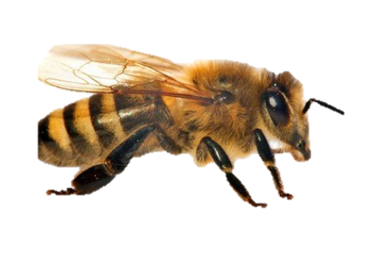
Wildlife Watch!
Draw a food chain for an animal you see in your garden or street! | Make a seed diary – draw pictures, take photos and write all about it. | Make a honey sandwich or honey pancakes and write instructions on how to make them. | Bees are endangered. Create a poster or a leaflet of another animal that is endangered.
Listen to the ‘Flight of the Bumblebee’ by Rimsky Korsakov. What instruments do you think are representing the bumble bee? | Beatrix Potter wrote a book about a hedgehog. Find out what it was called and read it. | Beehives have the 2D shape Hexagon in them. Draw 6 different hexagons. | Write instructions for your journey to school.
Write a poem about a bee or a hedgehog.  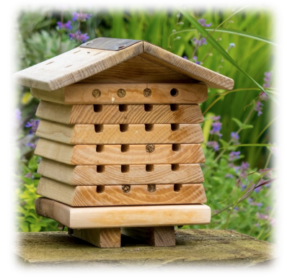 | Make a mini-beast habitat diorama.  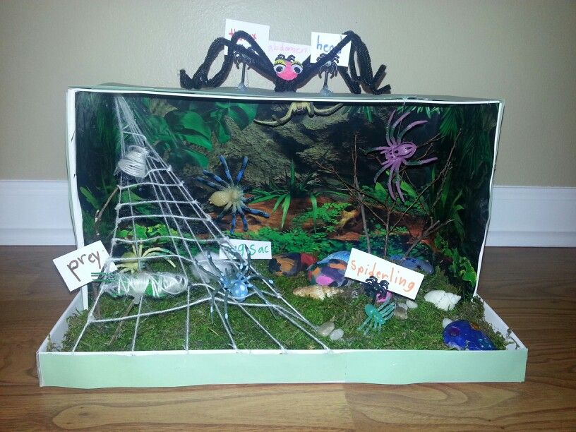 | Investigate a microhabitat in your area and write down what you find. | Find out the names of different types of hedgehogs around the world and the different countries they live in.
During the half term, pick and choose which activities you would like to complete as homework. You will receive 5 diddy dots for each task completed and returned to school. All completed homework needs to be returned to school by Monday 23rd July.

