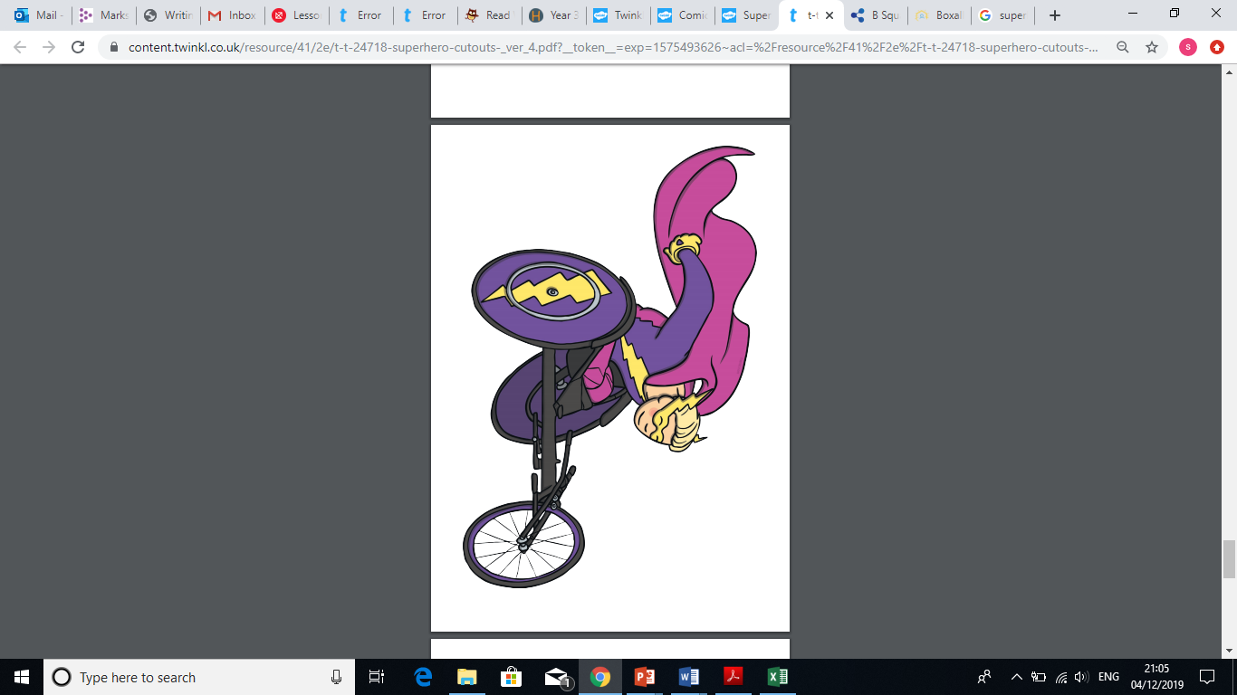
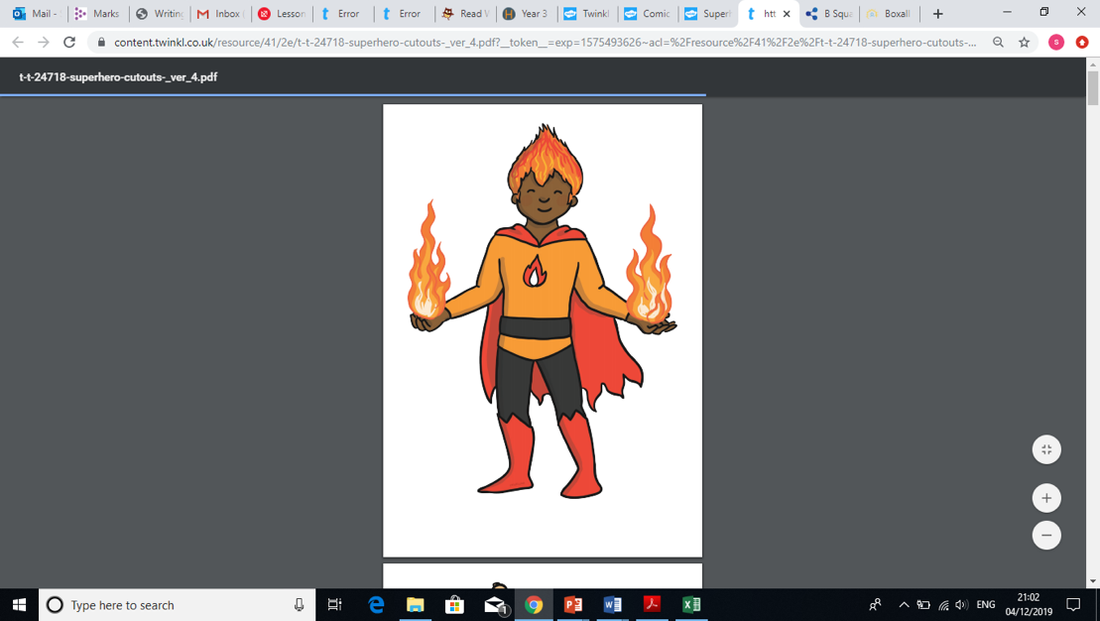
Diamond Class - Homework Spring 2
Sketch a picture of a superhero using the art skills we have been practising last term – stippling, hatching and cross-hatching. | Use recycled material to create a superhero. | What does a superhero do? Why are they important? | Write a poem about a superhero saving the world; think about what you would see and hear.
Research superheroes – who is your favourite and why? | Write a factfile about your favourite superhero – think about where they live, what their superpower is and what they look like. | Create your own superhero! What would they look like and what would their super power be? | Research superheroes and find as many different superpowers as you can!
List some questions you would like to ask a superhero. | What does a superhero wear? Do they need any equipment and why? | Design a maths problem that only a superhero could solve! | Imagine you were saved by a superhero! Write a story explaining this exciting experience.

What?
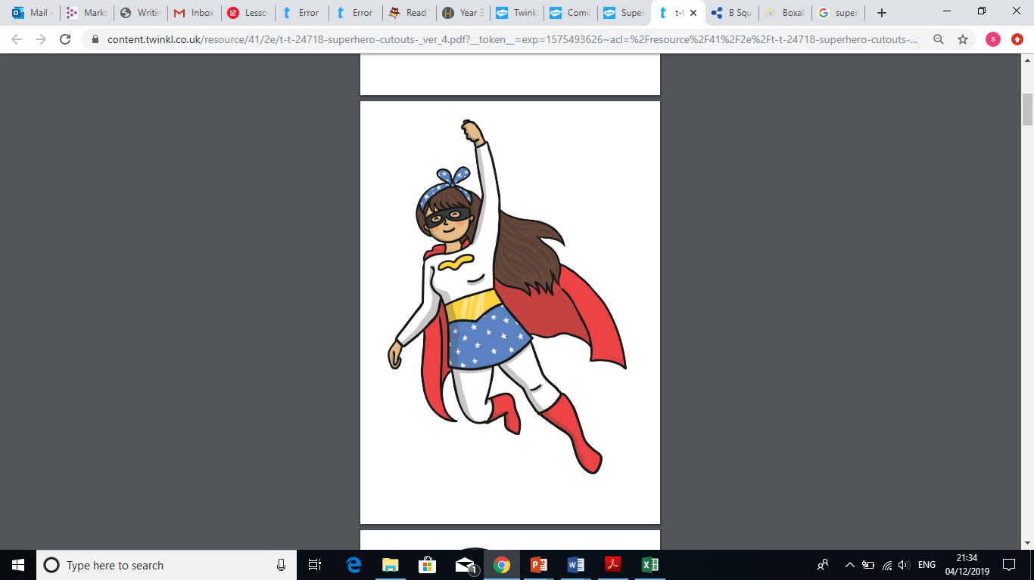
You can choose as many tasks as you like, making sure you take photos or record any writing. If you need a book or paper to record on, just ask! Some tasks are more of a challenge, so if you do a good job, you can earn extra diddy-dots!
When?
You have over the half term and during Spring 2 half term to complete the tasks. Return by Monday 30th March for marking and a reward!

