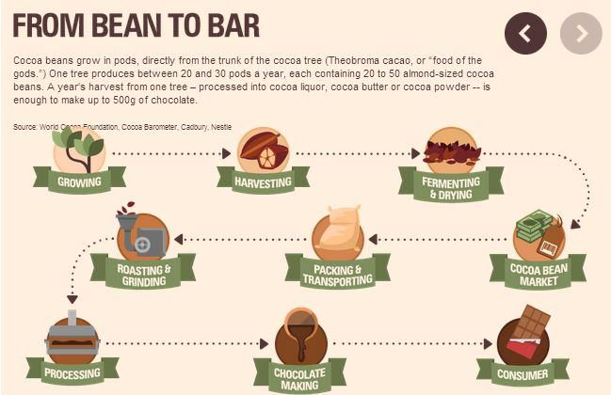

**Charlie and the chocolate factory**

Roald Dahl was a spy, an ace fighter pilot, a chocolate historian and a medical inventor.

Wanting the best for her only son, his mother sent him to boarding school - first to St Peter's, Weston-Super-Mare; then, in 1929, to Repton - where many bizarre and memorable events would later be recounted in his writing. Pupils at Repton were invited to trial chocolate bars, a memory that stayed with Dahl throughout his life, inspiring Charlie and the Chocolate Factory.

Would you like to go and trial chocolate bars? Why or why not?

If you had a chocolate factory and invented your own bar, what would you call it and why? What would be inside it?

Topic overview

In this topic children learn all about where chocolate comes from.

**The process of making chocolate**

**The chocolate journey**

1. The cocoa beans are collected.
2. The beans are roasted in an oven.
3. The beans are shelled and crushed.
4. The nibs are squashed to make cocoa liquor.
5. The cocoa liquor is mixed with milk to make a smooth liquid.
6. The liquid goes through a conching and tempering process.
7. The liquid is poured into moulds.
8. The bars of chocolate are wrapped up to keep them fresh.

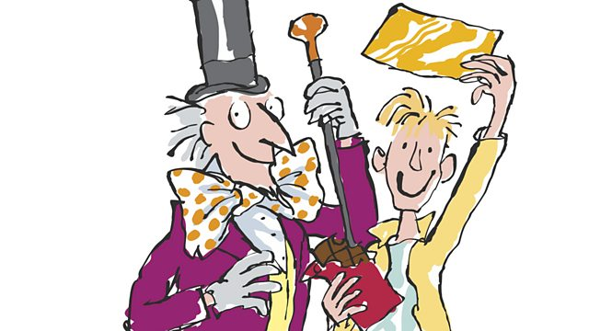

**Key Vocabulary**

**Equator –** An imaginary line around the middle of a planet. It is half way between the North Pole and the South Pole. An equator divides the planet into a northern hemisphere and southern hemisphere.

**Fair trade –** Fair trade is a way of buying and selling products that allow the farmers to be paid a fair price for their produce and have better working conditions.

**Climate –** The average weather conditions over a long period of time.

**Cacao trees –** A small tree that grows in tropical areas and it grows pods which contains seeds called cocoa.

**Harvesting –** To collect what has been planted and grown in the ground. This is usually done by farmers.

**Fermenting –** A chemical change that happens in vegetables or animal substances.

**Plantation –** A large area of land where crops are grown and harvested.

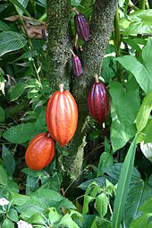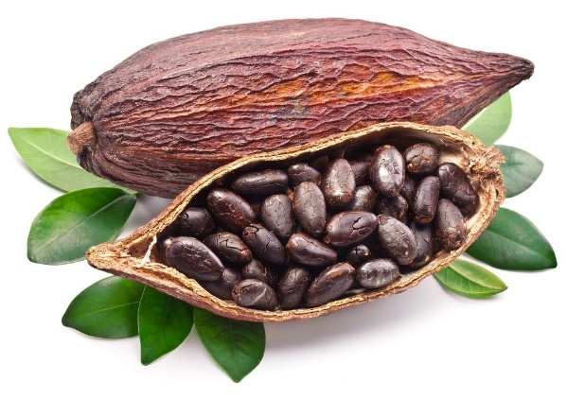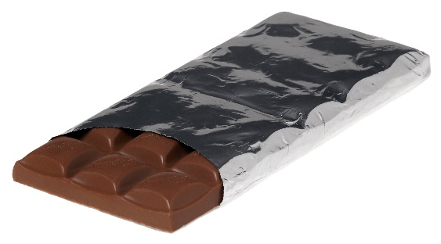

**SCIENCE – Plants!**

Your home learning science activity this half term is to plant this seed using the container and soil you have been given.

**Observe** (take a close look at) your plant once a week.

**Record** what it looks like and how much it has grown by measuring it with a ruler. If it hasn’t grown, record this too.

**Remember** – for a seed to grow it needs to be watered daily and to sit where it can see the sunshine.

**Report your findings** to me and take some pictures if you can!

