**Key people**

**Queen Victoria**

*1819-1901*

She was the queen of England and reigned for 63 years.

**Prince Albert**

*1819 - 1861*

He was married to the queen from 1840- 1861.

**Key Vocabulary**

**Queen Victoria**  – the Queen of England during the Victorian era.

**Prince Albert** – Queen Victoria’s husband.

**Past** – something that has already happened.

**Present** – something that is happening now or recently.

**Rich** – people that have lots of money.

**Poor -** people that have little money.

**Timeline** – events in the order in which they happened.

Topic overview

In this topic, children learn all about the Victorians and how they lived. We will explore aspects such as how they lived, what jobs they did and toys they played with.

**Key images**

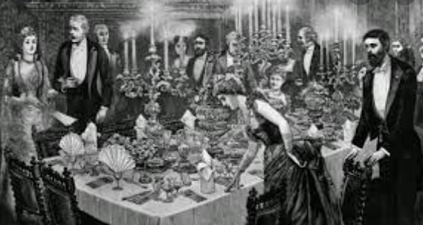 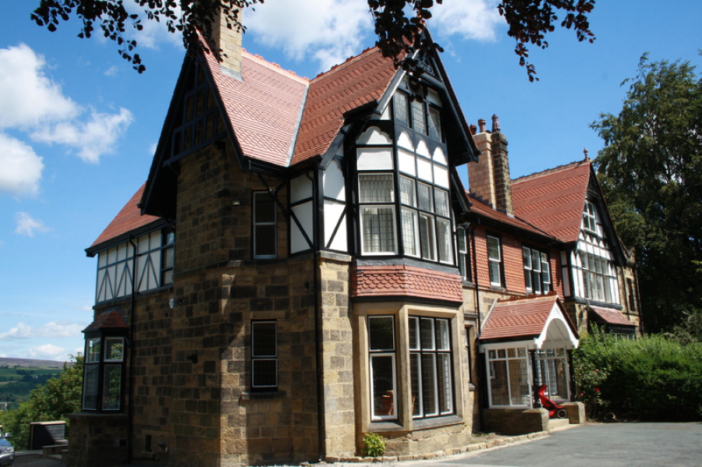 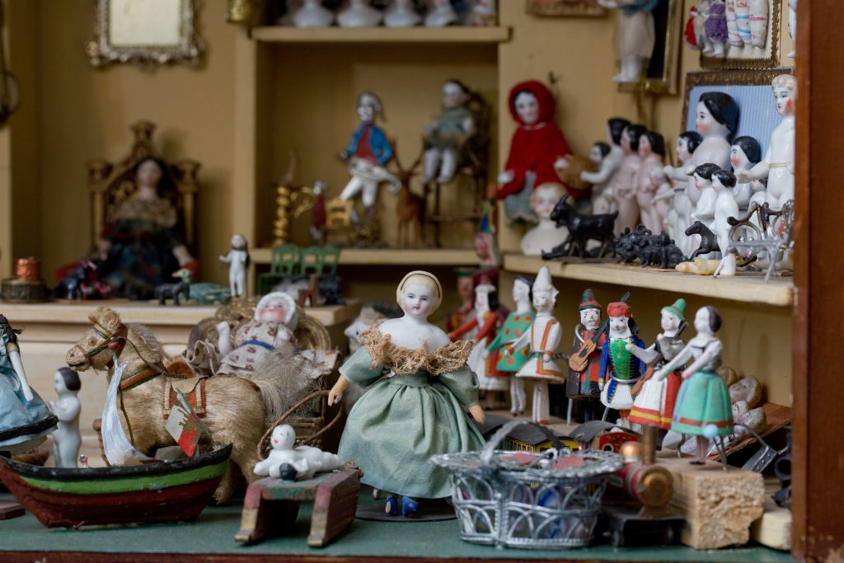

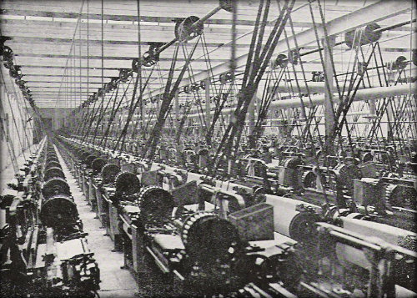 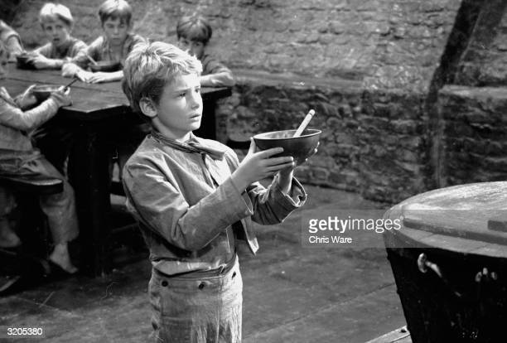

**Interesting facts**

* Queen Victoria’s first name wasn’t Victoria, it was Alexandria.
* Queen Victoria was the first royal to live in Buckingham palace.
* She became the queen when she was 18.
* She proposed to her husband.

Rich and poor Victorians lived very differently to each other. The rich enjoyed big houses and lovely feasts, while the poor had small houses and not a lot of food.

Victorian children played with toys, but they were very different to the toys we play with today. They played with dolls, spinning tops and teddies. A lot of Victorian toys were made from wood.

Rich Victorian houses were very big.

We will also learn about school life and take part in Victorian day!

Oliver Twist is a film that was set in the Victorian times about a boy who was sent to work in a work house, becomes a pick pocket and then finds a new home.

Victorian children worked in factories because they has small fingers. Lots of children lost fingers and arms as they would get caught in the machines

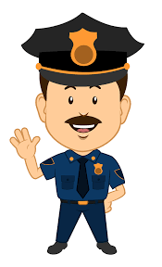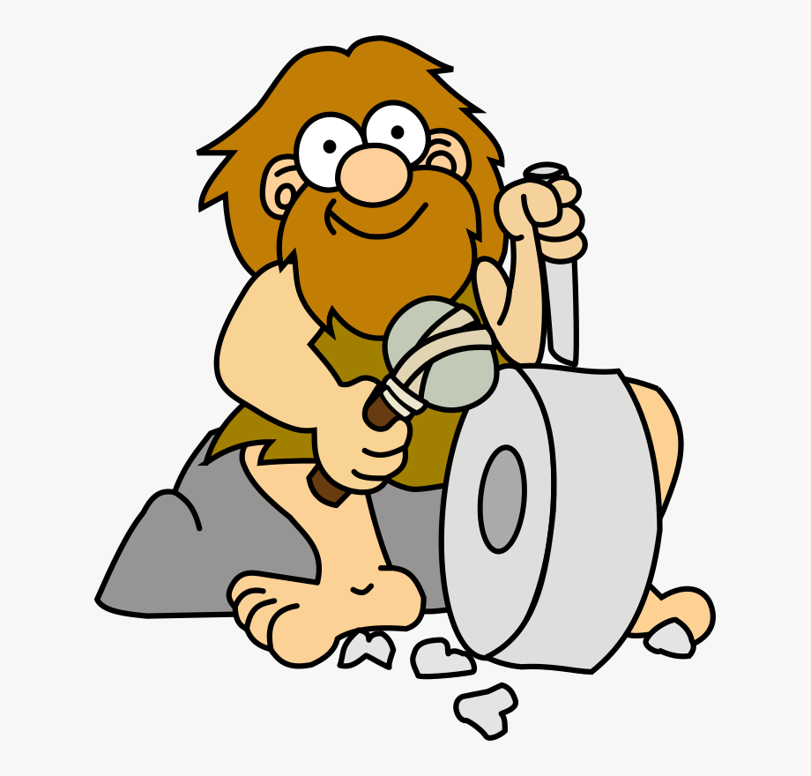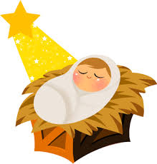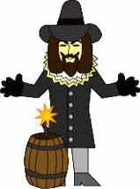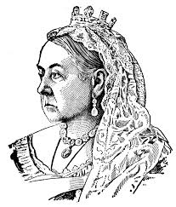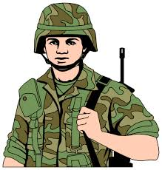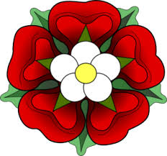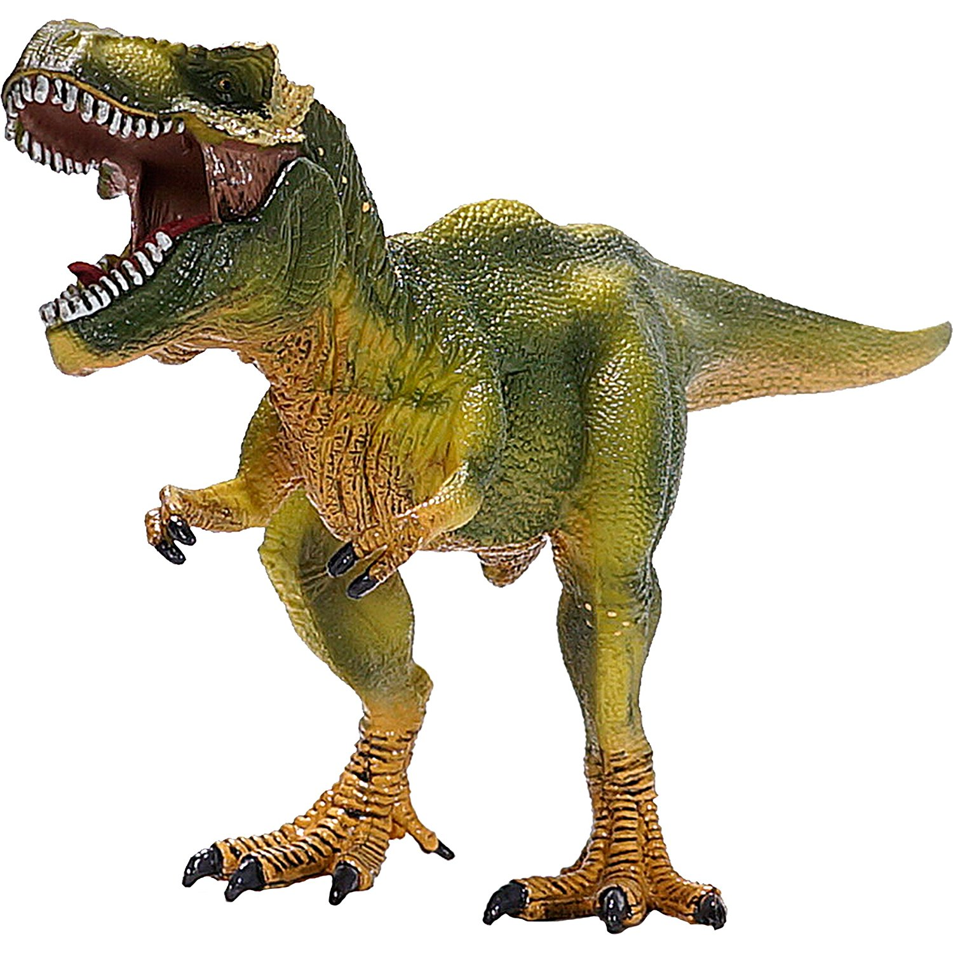

Our Timeline

Stone age (cave man)

Dinosaurs

Birth of Jesus

Victorians

Crimean War

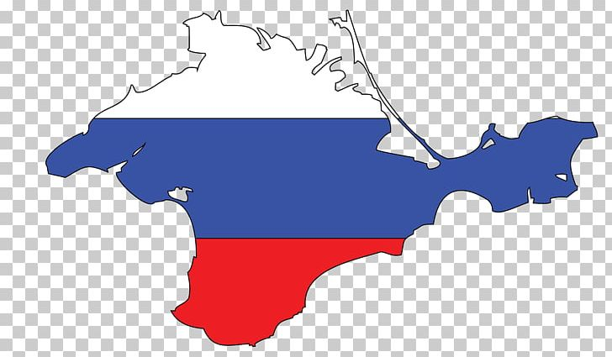

First police force

First flight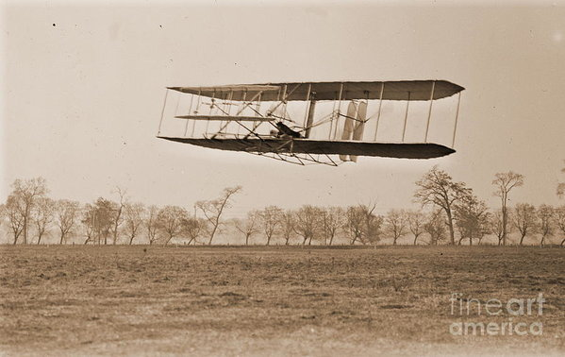

Gunpowder plot

Tudors

Word War 1