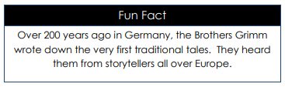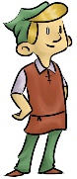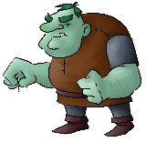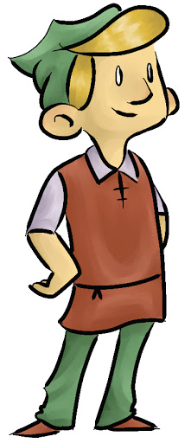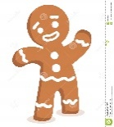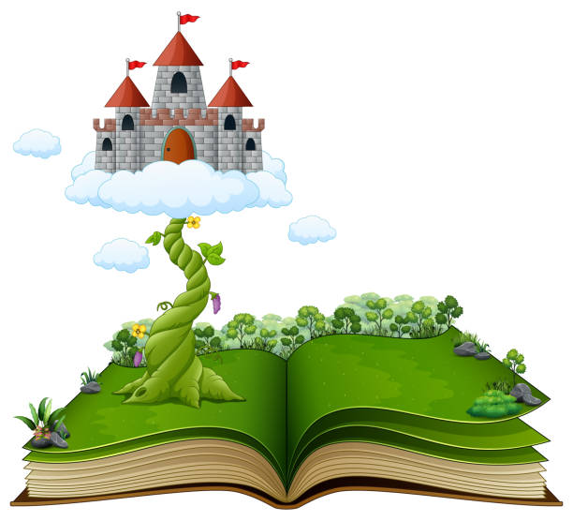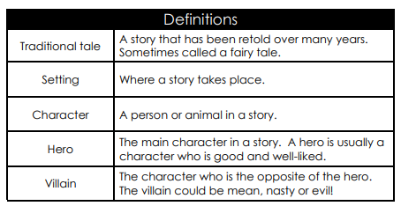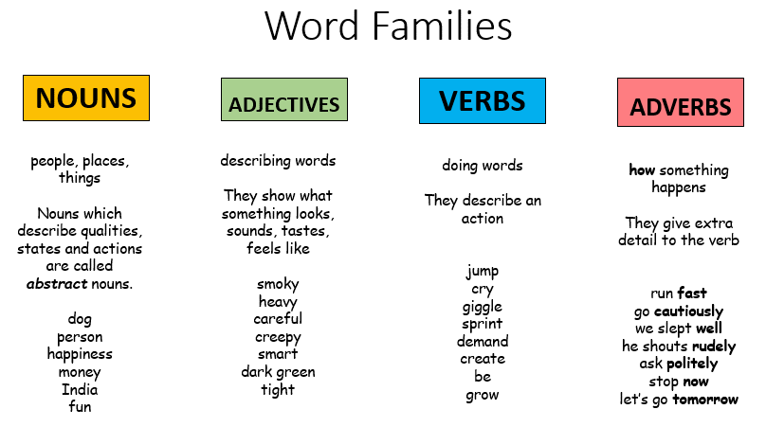

Word Families

**Can you read or retell any of the Grimm brothers’ fairy tales?**

Rapunzel 

Rumpelstiltskin 

Cinderella 

Snow White 

The Golden Goose 

Hansel and Gretel 

Thumbelina 

The Frog Prince 

The Elves & the Shoemaker 

Once upon a fairy tale…

Knowledge Organiser

Over 200 years ago in Germany, the Brothers Grimm wrote down the very first traditional tales. They heard them from storytellers all over Europe.

Nearly all traditional fairy tales have morals within them. This means that the tale teaches us an important lesson.

How something happens

They give extra detail to the verb

run fast

go cautiously

he slept well

he shouts rudely

ask politely

stop now

let’s go tomorrow

Doing words

They describe an action

jump

cry

giggle

sprint

demand

create

be

grow

Describing words

They show what something looks, sounds, tastes, feels like

smoky

heavy

careful

creepy

Smart

dark green

tight

People, places, things

Nouns which describe qualities. States and actions are called abstract nouns

dog

person

happiness

money

India

fun