**Year 2 - Knowledge Organiser**

**The Tale of Old Billy**

Children will learn about *Old Billy*, the world’s oldest recorded horse, and explore the changes in landscape and labour throughout history. Through *Talk for Writing*, they will write persuasive letters and poetry to honour his legacy.

Key Vocabulary

**Barge horse** – a horse used to pull boats along canals

**Canal** – a man-made waterway for boats

**Transport** -

**Why is Old Billy important?**

* He lived much longer than most horses.
* His story teaches us about **animal welfare** and how we treat working animals

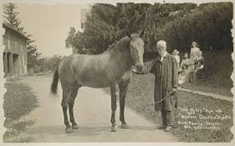

**Who was Old Billy?**

* *Old Billy* was a barge horse from Warrington, England.
* He was the oldest recorded horse in history, living for **62 years** (1760–1822).
* He worked pulling boats along canals for most of his life.
* His skull is kept in Manchester Museum.

**What was life like for working horses?**

* In the **18th and 19th centuries**, horses were used for heavy work,   
  such as farming, transport, and pulling barges.
* They had to work long hours in difficult conditions.
* Today, horses are often kept for riding and sports instead of hard labour.

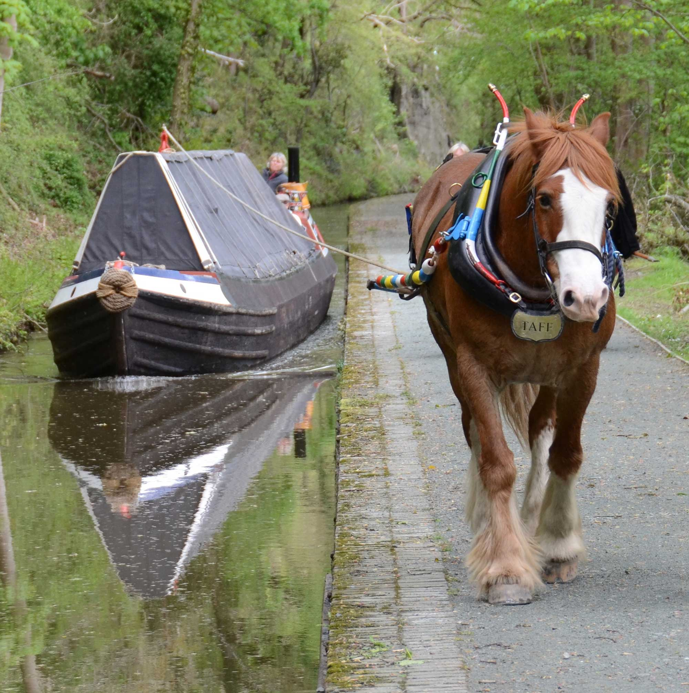

Old Billy was born in Woolston Worked at the Bridgewater Canal Retired at 59 years old Old Billy died at 62 years old

1822

1821

1819

1790ss

1760

Old Billy is bor

1810

1778

Started working as a barge horse at 18 years old Celebrated 32 years of work Painted by artist Charles Towne