Year 2 Homework for Spring 2 Half Term
Make a hand puppet of a character from a fairy tale | Find a gingerbread recipe and follow it to make your own gingerbread men | Write a letter from the wolf saying sorry to the three little pigs | 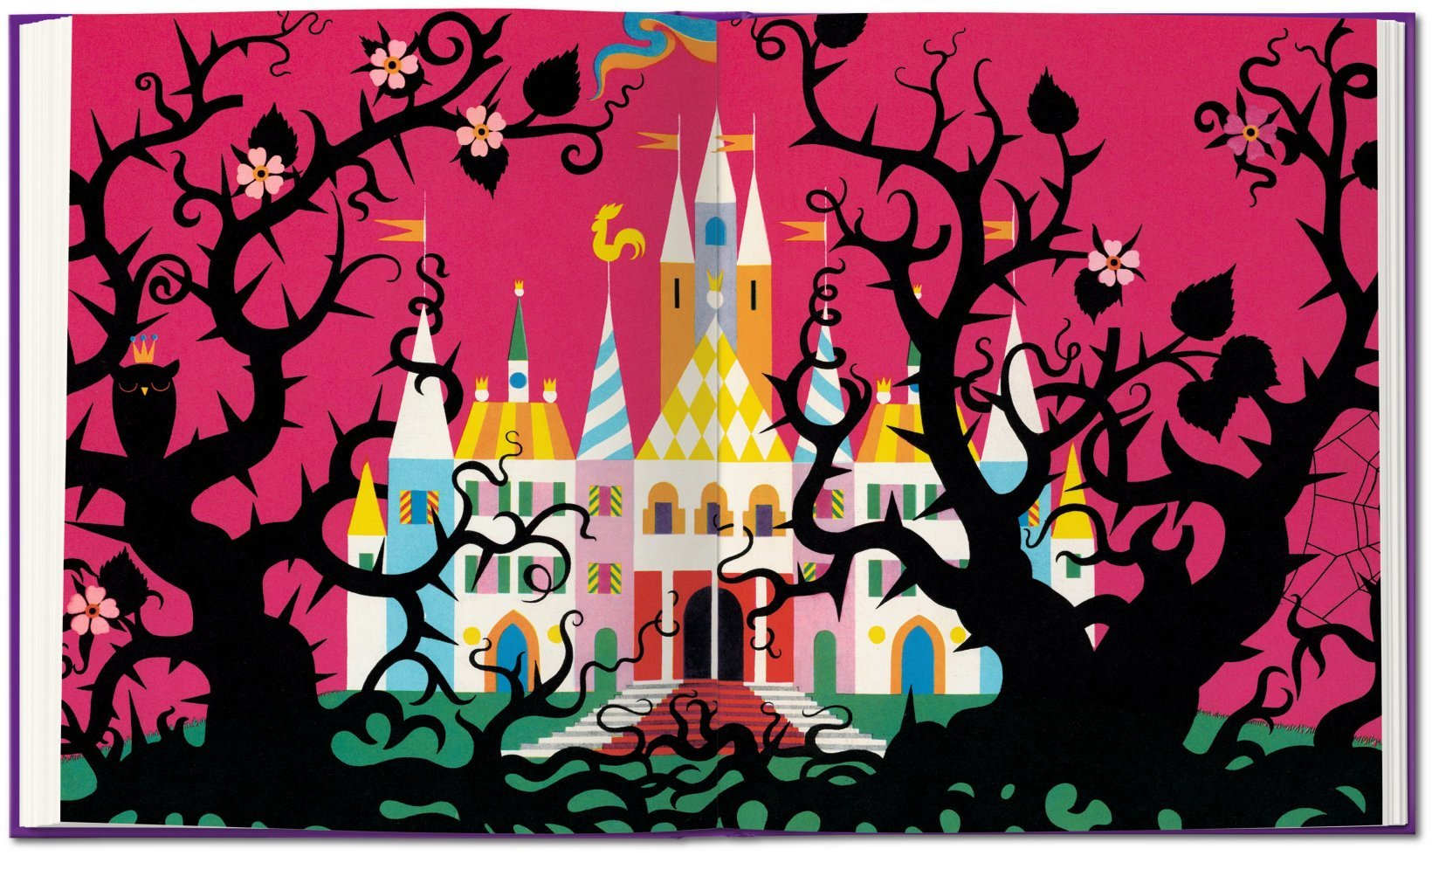  Visit a castle and write about your experience or research a castle you have already visited and write about it
Measure the plants in your garden and draw table/chart of your results. | Make a mask of an animal from a fairy tale | Create your own good or bad fairy tale character. You need to draw and colour a picture of your character and then write at least 3 sentences to tell me what your character is like. | Plant some runner beans or broad beans and grow a beanstalk
Change the ending of your favourite fairy tale | Use a shoebox to make a diorama of a fairy tale | With an adult, use the internet to research different fairy tales from around the world | Free choice  You can decide what to do based on our ‘Once upon a fairy tale’ topic

What?
You can choose as many tasks as you like, recording any writing in your homework book. Don’t forget to take pictures, too!
When?
You have over the whole half term to complete. Return for week beginning 31st March for a reward!

