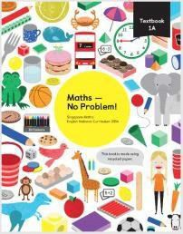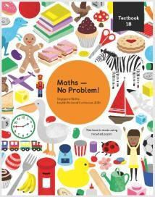
Bewsey Lodge Primary School Maths Curriculum Overview

 | Autumn 1 | Autumn 2 | Spring 1 | Spring 2 | Summer 1 | Summer 2
Year R | We will count to 5 using objects actions and sounds. We will also compare numbers of objects to 5. We will then order numbers to 5 and compare them. We will be making number Bonds to 5 which will include using Five's Frames. We will find one more and one less than five.  We will be looking at capacity by finding full and empty; full, empty & half empty; full, empty, half empty, half full.  We will count to 10 using objects actions and sounds. We will also compare numbers of objects to 10. We will then order numbers to 10 and compare them. We will be making number Bonds to 10 which will include using Ten's Fames. We will find one more and one less than fen. |  | We will be looking at 2D shapes. Recognising them and finding 2D shapes inside other 2D shapes. We will compare the height and length of three different objects. We will continue to count to 10 and writing the digits. We will be finding how many more make 10 ans number bonds to 10.  We will count beyond 10 – counting to at least 20.  We will subitise (recognising numbers without counting) with objects, dice, Five's and Ten's Frames. We will be sharing equally. We will be doubling numbers to 10 .We will learn how to halve small numbers by sharing objects and pictures. |  | We will name simple 3D shapes using mathematical language. We will find shapes inside 3D Shapes. We will rotate, compose and decompose them. We will recognise, create and describe our own repeating patterns. We will be ordering the day (First, Next, Then…). We will also look at the days of the week and months of the year. We will make a clock and tell the time to the hour. By learning through play, we will begin to understand that money has value and recognise coins.  We will be finding the difference between heavy and light and describing positions (on top, under, besides).
Year 1 | Numbers to 10  We will consolidate our understanding of the value of numbers to 10, including 0. We will be learning how to order, compare and understand all numbers to 10 and work with them fluently and accurately. We will begin to understand the concept of number bonds and we will begin to learn to record work to solve problems.  Number Bonds  We will consolidate our understanding of how two numbers can be added to make a bigger number. We will explore different ways to make numbers up to 10 and create stories from what we have learnt.  Addition to 10  We will find different ways of adding to 10. We will learn how to use the part-part-whole diagram and begin to lay the foundations of the inverse of addition. We learn to make our own addition equations in order to support the deeper understanding of the processes of addition.  Subtraction Within 10  We will learn that subtraction equations can be done in three | Positions  We will deepen our understanding of positional language (first, second, third), as well as directional language for left and right.  Numbers to 20  We will now look at numbers up to 20 and in particular focus on numbers between 10 and 20. We will be able to confidently count and write to numbers to 20, compare and order numbers and see patterns within 20.  Addition and Subtraction Within 20  We will learn different ways to add and subtract numbers within 20.  Shapes and Patterns  We will find out about different types of 2D shapes and some basic 3D shapes. We will be able to talk about the properties of basic 2D shapes and some solid shapes. We will learn to group shapes according to different criteria. This will also lead to recognising, describing and continuing a pattern, as well as generalising patterns. | Length and Height  We will begin to understand the concept of length. We will compare different lengths and describe whether something is taller, longer, shorter or higher. We will learn about how to measure two items fairly for comparison using items and body parts before moving onto measuring using a ruler.  Numbers to 40  We will be exploring numbers to 40 in a variety of ways. To start with, we will focus on counting to 40 in different ways and writing numbers to 40. Then we will compare numbers and look at number patterns.  Addition and Subtraction Word Problems  We will be counting, adding and subtracting in a real life context. We will use pictures and other representation to help us visualise problems. We will be applying our knowledge of number bonds and simple bar models to represent word problems. We will also be comparing - specifically looking at how many more or how many fewer/less. | Multiplication  We will learn the foundations of equal groupings, repeated addition, arrays and doubling. We will learn to apply this knowledge to solve word problems. We will be using images from our previous learning such as ten frames and number tracks.  Division  We will be learning how to share small numbers into a specific number of groups. Then, we will be given a number of items, but will need to work out how many will go into each group by sharing equally.  Fractions  We will be learning about making halves and quarters before moving on to making the connection between fractions and division. | Numbers to 100  We will begin by reinforcing our previous learning by counting in 10s and 1s. We will use our number bonds to partition numbers. Then will learn to compare numbers to 100 and find number patterns looking at one hundred charts.  Time  We will learn to tell the time to the hour and half hour, using terms such as 'next,' 'before' and 'after,' estimating durations of time and, finally, comparing time. We will be exploring analogue clocks and telling time to the hour and half hour. We will look at a timeline for an average day and then determine the order of events using specialised terminology. We will estimate lengths of time and then compare measures of time. | Money  We will be learning to recognise different coins and notes and using our number bonds to work out how much items cost.  Volume and Capacity  We will be learning to compare volume and capacity, using terms such as 'more than' and 'less than'. We will measure volume and capacity using non-standard units. We will be describing volume using the terms 'half' and 'quarter.'  Mass  We will be comparing mass using terms such as 'heavy/heavier,' 'light/lighter.' We will then measure mass using non-standard units.  Space  We will be exploring the important elements of position, movement and turns. We will be learning to describe the position of one object relative to another, using terms such as: 'top,' 'middle' and 'bottom;' 'around,' 'close,' 'near' and 'far;' and 'on top of,' 'in front of' and 'above.' When looking at movement, we will explore the concepts of 'up and down,'

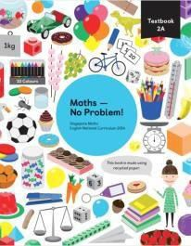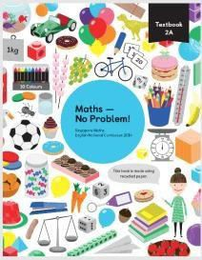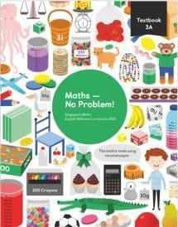
 | ways: by crossing out, by using  number bonds and by counting back. We will continue to use concrete apparatus and pictorial representations to support our understanding and we will learn to use maths vocabulary appropriately. |  |  |  |  | 'forwards and backwards,' and  'inside and outside.' We will learn about turns: navigating whole turns, half turns, quarter turns and the notion of clockwise and anticlockwise.
Year 2 | Numbers to 100  We will learn to count to 100, including counting up in 10s. We will compare numbers using what we know about place value knowledge. We will embed our number bonds and apply them. We will explore numbers to see patterns within 100.  Addition and Subtraction  We will learn to add and subtract mentally by applying our number bonds diagrams as well as using the standard column method.  Multiplication of 2, 5 and 10  We will be using concrete apparatus and images to investigate multiplication by 2, 5 and 10. We will learn to look for patterns in multiplication and we will understand the commutative law. | Multiplication and Division of 2, 5  and 10  We will learn about both the multiplication and division of 2, 5 and 10. We will look at different ways of sharing, including sharing and grouping before learning about division by 2, 5 and 10. We will also investigate links between multiplication and division and odd and even numbers.  Length  We will deepen our understanding of how to measure length. We will begin by understanding what a metre is and what centimetres are and then progress to using them in real-life contexts.  Mass  We will be learning about mass in the context of kilograms and grams. We will learn how to read scales, to compare the weight of different objects and to solve word problems in the context of mass. | Temperature  We will learn to measure temperature. We will learn about celsius, how to read thermometers and we will look at what kinds of temperatures we can measure.  Picture Graphs  We will learn how to read, interpret, analyse and construct our own picture graphs with confidence.  More Word Problems  We will be learning to use addition and subtraction to help solve word problems. We will learn to make the decision to use addition and subtraction. We will use the bar models to think about what is the same and what is the difference.  Money  We will learn to write and count money and we will learn to represent money using £ and p. We will be reinforcing previous  counting methods using 5s and 10s to count quickly and efficiently. We will learn to show equal amounts of money and to exchange money. We will solve problems involving money using bar modelling. | Two Dimensional Shapes  We will be learning about 2-D shapes and their different properties. We will explore how to draw shapes, make patterns with shapes and turn shapes using familiar language. We will be identifying sides of shapes and their vertices before moving on to lines of symmetry. We will recreate shapes using blocks and sorting the basic shapes before we learn to draw shapes using square grids and dot grids.  Three Dimensional Shapes Following on from our learning about 2D shapes, we will be learning to recognise, describe and group 3-D shapes, forming structures with them and making patterns using 3-D shapes. | SATs  We will take two standardised assessment tasks (SAT) – one arithmetic paper and one reasoning paper.  Fractions  We will embed our understanding that fractions are equal parts and will focus on halves, quarters and thirds. We will learn to name fractions of the same denominations. We will understand how many quarters, halves and thirds make a whole. We will explore how to order and compare fractions. We will count in fractions and begin to learn how to find fractions of a set of objects or part of a quantity. | Time  We will learn to tell the time to the nearest 5 minutes on analogue clocks. We will learn how to find the duration of time, the end of a length of time, the beginning of a length of time and, finally, compare lengths of time.  Volume  We will learn to compare volumes of containers, measuring in l and ml and solving word problems associated with volume.
Year 3 | Numbers to 1000  We will learn numbers to 1000 and focus on the value of each digit: place value. We will learn how to compose and decompose numbers, compare, order and look for patterns.  Addition and Subtraction  We will learn to use formal methods of addition and subtraction where regrouping is required. We will learn to solve problems using addition and subtraction, using the bar model as a visual aid. | Multiplication and Division  We will learn to multiply and divide by 3, 4 and 8. We will then use this experience of multiplication and division to solve word problems.  Further Multiplication and Division We will learn to multiply and divide using both informal and formal methods. We will solve problems such as missing number problems and scaling problems. | Length  We will embed our understanding of measuring length in metres and centimetres before moving on to kilometres. We will learn to convert different units of measurement as well as compare different lengths. We will solve in which we will use our mental and procedural skills to solve problems with the aid of the bar model.  Mass  We will be using scales to measure mass in g and kg, reading scales that have different values for each | Money  We will embed our previous learning on recognising different denominations (both notes and coins) and the simple addition and subtraction of money. We will then develop the concepts related to addition and subtraction of money using number bonds as a key method. We will then apply our new knowledge to solve word problems using bar modelling as a key strategy.  Time  We will tell the time using 'am' and | Picture Graphs and Bar Graphs We  will be learning about how to create and interpret picture graphs and bar graphs. We will create picture graphs where the pictures can represent more than 1 item.  Then, we will start to create bar graphs. We will then read and interpret information from bar graphs.  Fractions  We will begin by counting using fractions and then making number pairs (the fraction equivalent to number bonds) before moving on | Lines and Shapes  We will be exploring different types of lines in addition to properties of shapes, both 2- and 3-D. We will learn to identify perpendicular and parallel lines, followed by horizontal and vertical lines. We will learn the vocabulary to describe 2- dimensional shapes and learn to draw them before making 3- dimensional shapes using nets and clay.  Perimeter of Figures  We will learn to measure the total length around a shape to find its

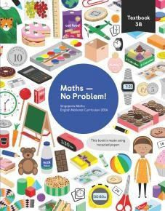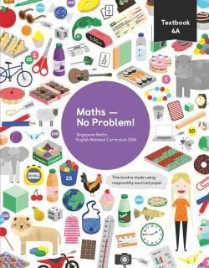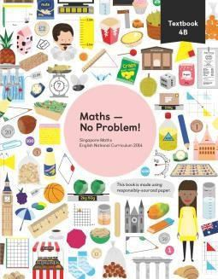

Numbers to 10 000
Year 4
We will embed our understanding of number by counting to 10 000 in multiples of 25, 100 and 1000. We will develop our understanding of place value by using concrete apparatus to represent numbers.
We will compare and order 4 digit numbers and learn to create and interpret number patterns by using our knowledge of place value. We will learn to round numbers to the nearest 10, 100 and 1000 and use this knowledge to estimate numbers. We will begin to understand that numbers less than one exist.

Addition and Subtraction within 10 000
We will learn to add and subtract with numbers up to 10 000. We will learn mental methods and column methods for addition and subtraction. We will be encouraged to think about when is the most appropriate time to use each method. We will use the methods taught to solve word problems: visualising the problems using the bar model.

Multiplication and Division
We will learn how to multiply and divide by 6, 7, 9, 11 and 12. We will begin to understand mathematical vocabulary such as 'quotient' in relation to division. We will learn how to calculate multiplication equations using the multiplication facts that we know. We will understand the difference between sharing and grouping and we will understand the commutative law in multiplication. We will also solve problems involving multiplication and division.

Further Multiplication and Division We will further develop our understanding of multiplication and division. We will learn how to divide and multiply by 1 and 0 and understand the law of commutativity. We will learn how to multiply three numbers together using our knowledge of multiplication tables. We will use our tables and knowledge of place value to multiply multiples of ten leading to the multiplication of 2- digit numbers using short multiplication. We will use our knowledge of multiplying multiples of ten when multiplying multiples of 100 leading to multiplying 3-digit numbers using short multiplication.
marking. We will then solve some challenging word problems using the bar model.

Volume
We will learn to measure volume using millilitres and litres. We will solve a range of problems involving volume and capacity.

Completion of Further Multiplication and Division
We will learn more about division and will divide 2-digit numbers using chunking and short division: this includes numbers with remainders. We will learn to solve multiplication and division problems using the methods we have learned and will use the bar model to help visualise what the problem is asking us to do.

Graphs
We will learn how to interpret picture graphs and bar graphs. We will be introduced to line graphs and how they are used to measure change over time. We will interpret line graphs and use information collated in a table to draw a line graph. We will learn to make predictions based on trends identified in data.

Fractions
We will be using concrete apparatus to learn about mixed number fractions and improper fractions. We will learn about hundredths using concrete apparatus. We will learn how to convert between mixed numbers and improper fractions. We will learn how to add and subtract fractions and we will solve addition and subtraction word problems.
'pm', telling the time to the minute, using analogue and digital time and telling time by using both the minute and hour hands. We will then learn to use the 24-hour clock and clocks using roman numerals. We will understand how to measure and compare time in seconds, hours and minutes. We will convert units of time and then find a number of days in lengths of time.

Time
We will embed our learning about the 24-hour clock. We will learn how to convert between the 12- hour clock and the 24-hour clock. We will learn to convert between units of time, such as minutes and seconds, and hours and minutes. We will learn how to solve time problems involving conversions and calculating durations of time.

Decimals
We will be learning how to count, order and record the decimals in different ways. We will begin to understand the equivalence between tenths and hundredths and will be able to compare and order the numbers. We will learn to create number sequences using decimals as well as rounding decimals to the nearest whole number. We will explore the link between tenths and hundredths and dividing by 10 and 100.
to adding and subtracting fractions. We will explore equivalent fractions and look at simplifying fractions before comparing fractions with different denominators. We will be finding fractions of whole numbers as part of set and looking at sharing 1 and more than 1. We will apply our learning to solve increasingly sophisticated word problems.

Money
We will be learning how to count and record in pounds and pence. We will make links between tenths and hundredths and decimal notation for money. We will learn how to compare amounts of money by looking at significant digits and by converting amounts from pounds to pence and vice versa. We will learn how to round money to the nearest pound and we will understand contexts in which this would be a useful skill to know, like estimating. We will apply our learning to problem solving - finding totals and calculating change. We will be suing the bar model to visualise money problem. We will begin to explore unequal sharing in the context of money.

Mass, Volume and Length
We will be learning how to estimate and measure mass, volume and length. We be learning how to convert units of measure from larger to smaller and vice versa. We will embed our understanding of measuring perimeter using cm and mm. We will solve problems involving mass, volume and length.

Area of Figures
We understand the concept of area by measuring surface coverage: i.e. counting squares before measuring area by using multiplication. We will find areas of figures that have squares and rectangles by counting and visualising. We will learn how to apply our knowledge of finding area of figures in different orientations.
perimeter before moving onto grid paper to measure the combined lengths of each side. We will learn to calculate perimeter by adding all of the lengths together. We will learn to solve problems using perimeter.

Geometry
We be learning to name and compare angles and use this information to help us when classifying triangles and quadrilaterals. We will explore symmetry and symmetrical figures before applying this knowledge to the completion of symmetrical figures. We will draw lines of symmetry on shapes and figures and will combine this knowledge and understanding to sort a variety of 2-D shapes.

Position and Movement
We will be learning how to describe the positions of objects and figures. We will understand how we can describe positions on grids using coordinates. We will be introduced to the x and y axes and how coordinates are written. We will learn how to translate shapes using the language of 'left', 'right', 'upwards' and 'downwards' and will use coordinates to describe a figure following a translation.

Roman Numerals
We will learn to write the Roman numerals to 100, exploring the patterns involved and exploring other concepts of number whilst learning about this number system.

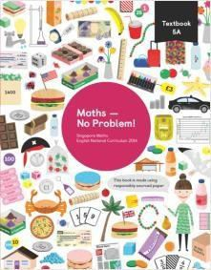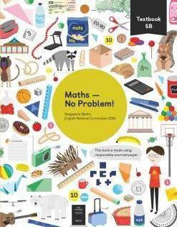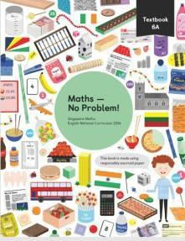
Year 5 | Numbers to 1 000 000  We will be looking at numbers and their place value to 1 000 000. We will learn to read and write numbers to 100 000, quickly moving onto  numbers to 1 000 000. We will use concrete materials to represent numbers to 1 000 000, including number discs and place-value charts. We will learn to compare numbers to 1 000 000 using our knowledge of place value. We will explore number patterns and learn to round numbers to the nearest 10, 1000, 10 000 and 100 000.  Whole Numbers: Addition and Subtraction  We will be exploring addition and  subtraction of numbers to 1 000  000. We will learn to use simple strategies to add and subtract, such as counting on and counting back. We will then focus on adding within 1 000 000 and subtracting within 1 000 000. We will learn to use a range of methods, such as the column method and number bonds to add and subtract numbers. We will use concrete materials to improve our visualisation and mental skills. | Whole Numbers: Multiplication  and Division  We will be learning to multiply and divide 3- and 4-digit numbers by single- and double-digit numbers. We will be finding and defining multiples, factors and common factors. We will begin to work with prime numbers and determine what makes a number prime or composite. We will then learn about square and cube numbers before moving on to multiplying and dividing by 10, 100 and 1000. We will be using a variety of methods, including: number bonds, column methods and the grid method.  Whole Numbers: Word Problems We will be challenging ourselves to apply our learning of all four operation to solve multiple step word problems. We will be using the bar model and other visual representations to help visualise word problems. | Graphs  We will be learning to read and interpret information in tables and in line graphs. We will be deepening our understanding of time as we read increasingly complex timetables. We will be comparing line graphs and bar graphs.  Fractions  We will be learning to use more diverse problems involving fractions, including dividing and multiplying fractions by whole numbers. We will be supporting our learning with concrete apparatus and diagrams to help visualise fractions. We will learn to add and subtract fractions with different denominators and fractions represented with mixed numbers and improper fractions. We will begin to multiply fractions by whole numbers and multiply mixed numbers by whole numbers. We will solve problems involving fractions using the bar model. | Decimals  We will be learning to read and write decimals to thousandths, using concrete apparatus to support our learning. We will order decimals using our understanding of place value. We will explore the link between hundredths and thousandths written as fractions and decimals. We will apply our understanding of addition and subtraction to add and subtract decimals.  Percentage  We will learn to link hundredths to other equivalent fractions. We will then understand how other fractions can be shown as ‘out of 100’ and write this as both a decimal and percentage. We will then calculate percentages. | Geometry  We will be learning how to measure angles in degrees using a protractor. We will explore the angles that make 180° or straight line and those that make a full turn. We will practice drawing lines and angles accurately and use this to create accurate drawings of 2D shapes. We will apply our understanding of angles to solve problems involving angles. We will learn what a polygon is be able to name regular polygons.  Position and Movement We will be embedding our understanding of writing co- ordinates of points. We will understand how to translate and reflect shapes on a grid. We will be able to solve problems involving translations and reflections of shapes.  Measurement  We will embed our understanding of how to convert between different units of length, mass and time. We will learn to use negative numbers when reading scales, such as thermometers. We will solve problems involving measurements. | Area and Perimeter  We will embed our understanding of how to calculate area and perimeter of shapes. We will be learning how to use scale diagrams to find the area and perimeter of figures. We will understand how to estimate area and when this might be useful.  Volume  We will be learning how to find the volume of solid shapes. We will explore how we can find the compare the capacity of cuboids. We will understand how to convert between units of measurement for volume, estimate volume and solve word problems involving volume.  Roman Numerals  We will be learning to read and write Roman numerals up to 1000 and writing years in this way.
Year 6 | Numbers to 10 million  We will refine our knowledge of place value, working with numbers between 1 000 000 and 10 000 000. We will use concrete apparatus, numerals and words to represent numbers. We will round and compare numbers to 10 000 000, and place them in order from smallest to greatest.  Four Operations on Whole Numbers  We will learn to create and solve expressions involving brackets, exponents, multiplication, division, addition and subtraction. We will then be multiplying 3- and 4-digit | Fractions  We will refine our understanding of simplifying fractions using concrete apparatus and use this understanding to order fractions from the smallest to largest. We will learn to add and subtract fractions with different denominators, using pictures and diagrams to support our learning. We will extend our understanding to add and subtract mixed numbers. We will learn to use pictorial and abstract methods to multiply and learn how to divide fractions by a whole number.  Decimals | Measurements  We will learn to convert units of measure using fractions and decimals. We will apply our knowledge to length, mass, volume and time.  World Problems  We will be learning to solve increasingly complex word problems using the 4 operations and bar model diagrams. We will be learning to use high-order reasoning skills to solve problems and we will also be creating and solving our own word problems.  Percentage | Ratio  We will be learning to compare quantities and use fractions to represent this. We will learn to use the language of ratio: ‘for every..’. We will then solve problems using ratio.  Algebra  We will be learning how to understand pattern using concrete apparatus and we will learn how to tabulate to help identify patterns. We will begin to understand how we can express the relationships between two numbers using a symbol or a letter. We will learn how to write algebraic expressions | SATs  We will take three Standardised Assessment Tasks in Mathematics: an arithmetic paper and two reasoning papers  Volume  We will be developing our understanding of volume as it relates to cubes and cuboids. We will use concrete materials to understand the meaning of volume thoroughly. We will then determine a formula for the volume of cubes and cuboids, estimating volumes and calculating total volumes with a formula. We will solve problems | Position and Movement  We will be learning how to describe positions of shapes on a grid in all four quadrants. We will learn to describe translations and reflections in all four quadrants. We will learn how we can use algebraic expressions to describe a position or a movement of a shape.  Graphs and Averages  We will be deepening our understanding of the mean as an average and solve problems using the mean. We will learn how to read pie charts and line graphs with more complex scales. We will solve problems involving graphs and pie

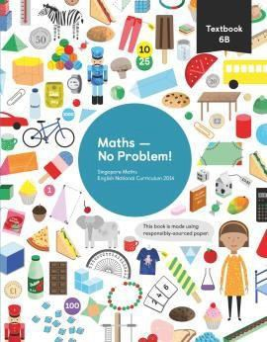
numbers by 2-digit numbers using
number bonds and column multiplication as the key methods. After this, they we will learn to estimate the products of multiplication sentences before moving onto division. We will be learning to divide 3- and 4-digit numbers by 2-digit numbers using a variety of methods, including number bonds and long division. We will strategies to solve more complex word problems involving multiple operations, including multiplication and division, using the bar and other pictorial methods. We will deepen our understanding of common multiples, common factors and prime numbers.
We will deepen our understanding
of reading and writing decimals using base ten materials before moving on to dividing and multiplying decimals by 1-digit numbers with no regrouping or renaming. We will learn how to write fractions as decimals using division and pictorial methods before moving on to multiplying decimal fractions. We will learn to divide decimals by 1 and 2 digit numbers using a variety of methods, including: number bonds, the worded method, long division and the column method.
We will be exploring how to
calculate percentage of numbers and quantities. We will learn how to solve for percentage change and use percentage to compare amounts. We will learn how to find the percentage of a quantity, measured in amounts such as litres and millilitres. We will learn how to use percentage to compare numbers and amounts.
for each of the four operations. We
will learn how to write and use formulae.

Area and Perimeter
We will be exploring how to calculate the area of rectangles, triangles and parallelograms.
related to volume, using division
and multiplication.

Geometry
We will explore angles and discover rules for opposite angles and adjacent angles. We will explore angles in quadrilaterals and triangles. We will learn to name the parts of a circle and investigate angles within a circle. We will practise precision drawing of quadrilaterals and triangles. We will explore the nets of three dimensional shapes and learn to draw them accurately.
charts.

Negative Numbers
We will consolidate our understanding of negative numbers by learning how to add and subtract using them. We will learn to use negative numbers in context.

