Macintosh HD:Users:nmuia:Pictures:Logos:Bewsey Logo .eps

# Singapore Maths

# Bewsey Lodge Primary School

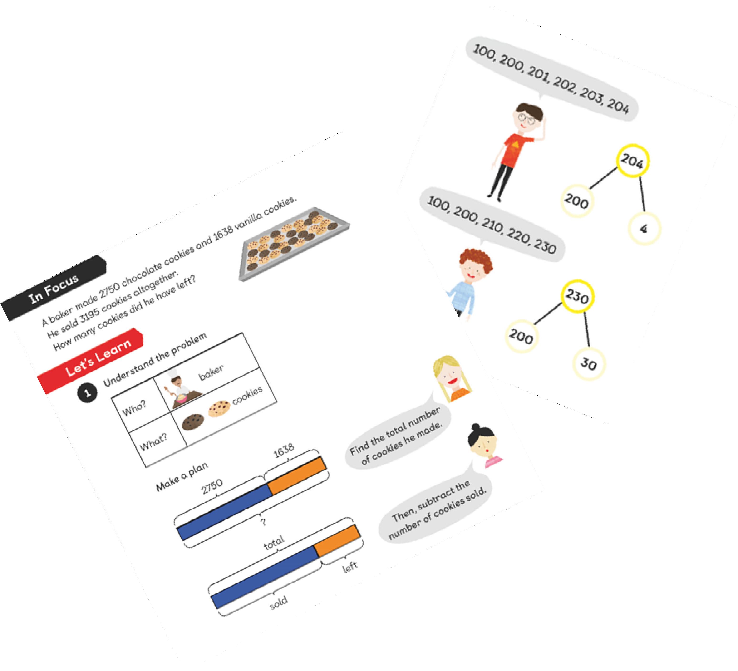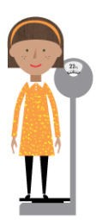



Rationale of Singapore Maths

The Singapore method of teaching mathematics develops pupils’ mathematical skills and confidence without having to resort to memorising procedures to pass tests- making mathematics more engaging and interesting.

Borrowing heavily from the Cockroft report (1982) the emphasis of the programme is all on problem solving. In all the material you will find that the teaching focuses on the use of three core competencies: Visualisation, Finding Patterns, and Mental Strategies. The Singapore method of teaching mathematics is based on research from a variety of sources. The work of educational psychologist Jerome Bruner, Richard Skemp’s work on relational and instrumental understanding, and the work of Zoltan Dienes on systematic variation.

# What is maths mastery?

The concept of teaching mathematics to mastery is to ensure that topics are well developed. Pupils will spend enough time to fully explore a concept before moving on to a different topic.

As an idea is well formed they are reinforced by plenty of practice. New knowledge is then used on subsequent lessons so that all ideas build on top of each other and pupils have ample opportunity to develop relationships between the topics.



# The CPA Approach

One of the key aspects of teaching Singapore maths is the CPA approach- concrete, pictorial and abstract. This approach is based on research by psychologist Jerome Bruner, who suggests that there are three steps necessary for pupils to develop an understanding of a concept. Reinforcement is achieved by repetition of these representations.

## Step 1: Concrete representation

Pupils are introduced to an idea or skill by using real objects to represent the problem. In addition for example, this may be done by adding 432+521= using 100’s, 10’s and units blocks. This is a “hands on approach” using real objects, and is a foundation for conceptual understanding.

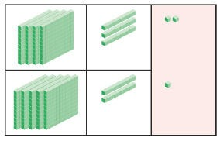

## Step 2: Pictorial representation

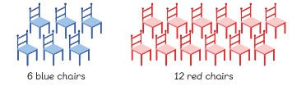Once pupils have understood the concrete experience they can now relate this to pictorial representations, such as a diagram or picture of the problem. In an example of the addition exercise, this could be the process of counting each object.

## Step 3: Abstract representation

Pupils are now able to represent problems by using mathematical notation, for example: 10 + 24 = 34

***The CPA approach is used to introduce new concepts from Year 1 to 6***

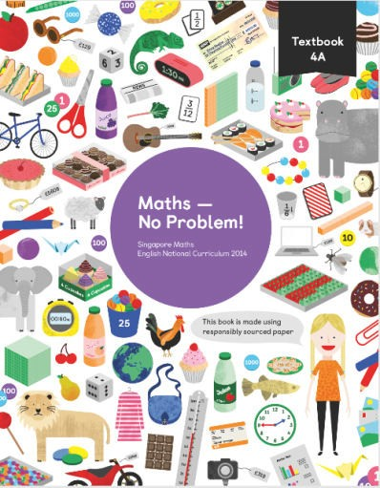

# Textbooks and Workbooks

The textbooks are used daily to inform teaching and allow teachers and pupils to explore topics in depth.

The textbooks include “Let’s learn” methods, guided practice

questions and group activities which form each lesson. The varied examples in each book have been chosen to stretch pupils into harder concepts and create dialogue between teachers and pupils.

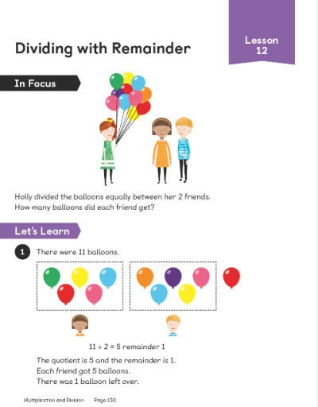

All children have an individual Singapore workbook. They are extremely learner friendly and include very simple visual representations for children to understand.

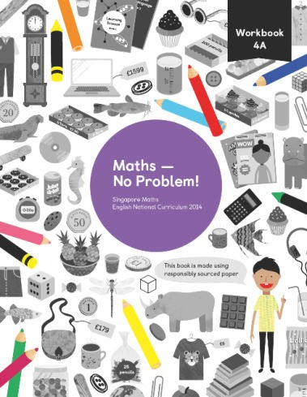 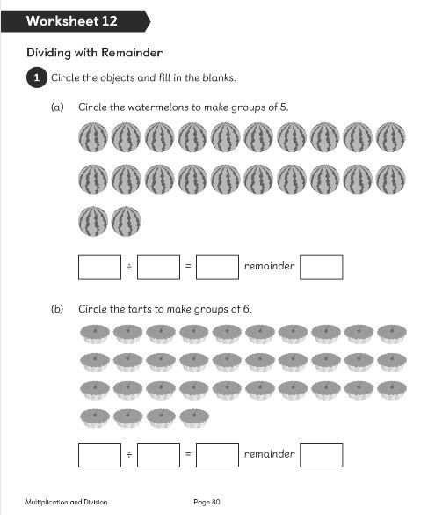

The workbooks allow children to work independently, demonstrating their understanding of the concepts and methods to assess their learning.

# Lesson Structure

## Part 1- “Let’s learn”

All children are introduced to the problem for example:

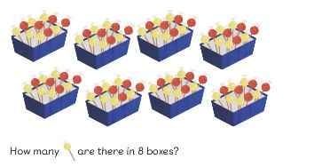

### Discussion:

The children discuss with a partner, then with the class teacher many way s in which the problem can be worked out, highlighting important vocabulary

### Methods:

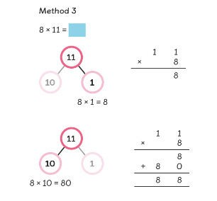

After the problem has been discussed, pupils are introduced to the different methods of solving the problem. Exposing children to this helps them actively try things out, and construct mathematical concepts to enrich their learning. At this stage children often use concrete apparatus to explore the methods.

This may be base 10 equipment, counters, place value counters, unifix cubes, coloured card and other resources.

## Part 2- Guided practice

Children are now able to put the methods into practice with various questions.

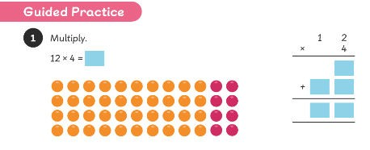

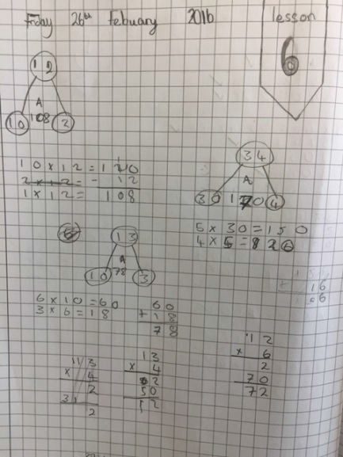The children use their maths journals to record their working out.

During guided practice, the children will continue to use the equipment given in part 1 of the lesson. Journaling is an opportunity for children to use the visual and written methods which work for them.



Part 3- Independent task in workbook

During independent practice, pupils have the opportunity to reinforce concepts by solving a range of problems in their workbooks.

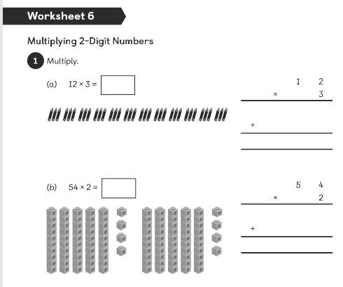

## Planning and Teaching

Using the online planning guide, teachers can receive guidance on the methods used in textbooks, questions to help promote deeper thinking, ways in which to differentiate for the less able children and ideas to extend the learning of more able pupils. Each lesson suggests an approach to use for the “let’s learn” task and the guided practice.



# The Bar Model

The bar model is a tool used by the children to visualise mathematical concepts and solve problems.

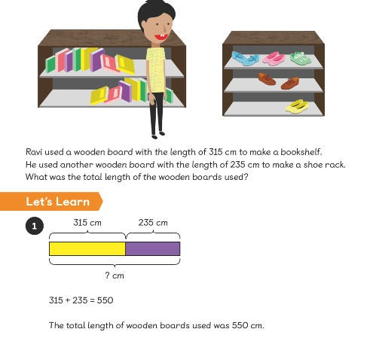

The bar model allows the problem to be represented in proportional and non-proportional diagrams that represent quantities. The children translate the information on the bars and manipulate the models to generate information in order to solve the problems.

Children also use this model for algebra and word problems in order to translate information into algebraic equations to solve for required unknowns.

